Alistana Fitness & Nutritional Tracker (AFNT)

Application

Ali Suhail

21072712

UXCFXK-30-3

Digital Systems Project



# Notice

The project files and code can be viewed at:

<https://github.com/alisuhail-amanu2/AFNT>

The Kanban board for the project can be viewed at:

<https://trello.com/invite/b/4r2w1F7l/ATTI108ef6ba22ae857e17384de5c89ba99117B65004/project-management>

# Acknowledgements

I extend my sincere appreciation to Martin Serpell for his invaluable guidance and support during the project's initial planning phase at UWE Bristol, before his retirement.

Furthermore, I would like to express my gratitude to Dr. Eman Qaddoumi for her continuous guidance and unwavering support throughout the module, which significantly contributed to the project's success.

Contents

Notice 2

Acknowledgements 3

Table of Figures 6

Table Content 7

Abstract 8

1. Introduction 8

2. Literature Review 10

2.1. Technological Advancements and Human Lifestyle 10

2.2. Benefits of an Active Lifestyle 11

2.3. Evolution and Rise of Health and Fitness Tracking 12

2.4. Fitness and Health Tracker Varieties 13

2.4.1. Common Categories of Fitness and Health Trackers 14

2.4.2. Evolving Trends in Fitness and Health Tracking 15

2.5. Effectiveness of Fitness Trackers 15

2.6. Understanding the Risks Associated with Fitness Trackers 16

2.7. Ethical Considerations 17

2.8. Development Research Plan 17

2.8.1. Success Criteria 19

2.8.2. Technical Knowledge 19

2.8.3. AFNT Evaluation Criteria 21

2.8.4. Requirements Gathering 23

3. Requirements 27

3.1. Requirement Structure 27

3.1.1. Requirement/Objective: 27

3.1.2. Phase Component: 27

3.1.3. Number: 27

3.2. Requirement Categorization 28

3.3. Usecase Diagrams and Descriptions 29

3.3.1. Usecase Diagrams and Descriptions 30

4. Methodology 36

4.1. AFNT Phases 36

4.2. Sprint Planning 38

4.3. Gnatt Chart 39

4.4. Trello Kanban Integration 40

4.5. Trello Kanban Advantages 42

5. Design 43

5.1. Phase 1: Database Design 43

5.1.1. Local Database 44

5.1.2. Servers 46

5.2. Phase 2 47

5.2.1. Admin Management Website Wireframes 48

5.3. Phase 3 48

5.3.1. AFNT Application Wireframes 49

5.3.2. AFNT Kivy GUI Class Structure 50

5.3.3. AFNT Class Structure 52

5.4. Phase 4 53

6. Implementation 54

7. Project Evaluation 55

8. Further Work and Conclusions 56

Glossary 57

Table of Abbreviations 58

9. References / Bibliography 59

Appendix A: Requirements 65

1. Project Aim 65

2. Project Objectives 65

3. Functional Requirements 65

3.1. Database 65

3.2. Website 67

3.3. Application 67

3.4. Arduino Watch 70

4. Non-Functional Requirements 71

4.1. Application: 71

4.2. Performance: 72

4.3. Efficiency & Sustainability: 72

4.4. Data Storage Optimization: 73

4.5. Privacy & Security: 73

4.6. Reliability: 73

4.7. Usability: 74

4.8. Data Backup & Recovery: 75

4.9. Third-Party Service Integration: 75

# Table of Figures

Figure 1: Life Expectancy 10,000 BC - Today (Cato Institute) 10

Figure 2: Fitness app annual users 2015-2021 11

Figure 3: Fitness in-app purchase revenue by app 2021 ($mm) 13

Figure 4: Fitness App Types. 14

Figure 5: Variables measured over a 36-week study for Type 2 Diabetic patient using Fitbit (Thomas William Miller, 2017). 15

Figure 6: Samsung Information Sharing Policy. 17

Figure 7: AFNT Initial Questions. 18

Figure 8: What I Need to Find Out. 19

Figure 9: Arduino Watch Components. 20

Figure 10: Assembly of All Arduino Watch Modules 21

Figure 11: First Version of Arduino Watch Interface (24/01/2024). 21

Figure 12: AFNT and Arduino Watch Evaluation Table. 22

Figure 13: Samsung Galaxy Watch (2018). 23

Figure 14: Fitbit Flex 2 (2016). 23

Figure 15: My Personal Workout Tracking Method Using Excel Spreadsheet. 25

Figure 16: My Personal Workout Data Using Excel – 2023 26

Figure 17: My Workout Progress Evaluation – 2023 26

Figure 18: Requirement Table Overview. 28

Figure 19: Usecase Admin Management Website. 29

Figure 20: Arduino Watch Usecase Diagram. 30

Figure 21: AFNT Project Kanban Board. 33

Figure 22: Project Labels on Trello. 33

Figure 23: Gnatt Chart. 35

Figure 24: Central Database Schema. 37

Figure 25: Local Database Schema. 39

Figure 26: Central Database and Admin Website Class Diagram. 40

Figure 27: Admin Management Website Usecase Diagram. 41

Figure 28: Admin Management Website Wireframes. 42

Figure 29: AFNT Class Diagram. 46

# Table Content

Table 1: Requirement/Objective Abbreviations. 27

Table 2: Phase Component Abbreviations. 28

Table 3: MoSCow Prioritization table. 28

Table 4: Admin Management Website Usecase description. 29

Table 5: Store Measured Data and the <<extend>> Usecase description. 30

Table 6: Sync Watch Data to Application Usecase description. 30

Table 7: AFNT App Usecase Diagram. 31

Table 8: Manage Workout and the <<extend>> Usecase description. 32

Table 9: Gym Finder Usecase description. 32

Table 10: Trello Kanban Column Descriptions. 34

Table 11: AFNT Phase Descriptions, 36

Table 12: Central and Local Database Schema Descriptions. 38

Table 13: Local Database Schema Descriptions. 39

Table 14: Database Server Descriptions. 40

Table 15: Admin Management Website Usecase Description. 41

Table 16: AFNT App Wireframes. 43

Table 17: AFNT Main Kivy GUI Class Definitions. 44

Table 18: AFNT Workouts and Exercises Kivy GUI class definitions. 45

Table 19: AFNT Meals and Food Items Kivy GUI class definitions. 45

Table 20: AFNT Class descriptions. 47

# Abstract

**Incomplete**

This research aims to address the global health challenge of high obesity rates by developing a secure fitness and nutritional tracker to assist individuals in achieving their health goals. The prevalence of obesity, particularly in developed countries, has led to widespread health and economic implications. This study seeks to raise awareness about the significance of good health, emphasizing the positive mental effects associated with fitness.

The primary objective is to create an accessible software solution that encourages health-conscious behaviour and to increase awareness about the benefits of exercising regularly which can help minimize the healthcare burden and lower the risks of diseases and illness. The relevance of this research is underscored by the urgent need to combat the obesity pandemic and understand its far-reaching consequences on both society and the economy.

The anticipated outcomes include fostering a global culture of health consciousness, where individuals comprehend the profound benefits of good health. The research also endeavours to produce an easy-to-use program, empowering users to navigate their fitness journey effectively. By promoting higher fitness levels, the research aspires to contribute to a healthier population, subsequently mitigating the risks of diseases and alleviating the strain on healthcare systems. This project serves as a comprehensive test of software development and planning skills, aimed at making a substantial impact on public health and well-being.

# Introduction

**Incomplete**

Currently, one of the biggest challenges the world is facing is a global obesity pandemic, which has become an especially acute problem in the developed world. According to The Guardian, around 38% of the global population, approximately 2.4 billion people, are currently categorized as overweight or obese. Without the widespread adoption of measures such as taxing and limiting the promotion of unhealthy foods, this trend is expected to persist. By 2035, it is predicted that the percentage of clinically obese individuals will rise from one in seven to one in four, with more than half of the total population being obese or overweight (Campbell, 2023). Having said that, the rapid increase of obesity rates will lead to higher chances of diseases and illnesses, which will have a greater burden on the healthcare sector and the overall productivity of the economy (‘Obesity Consequences’, 2012).

The key contributors of obesity and overweightness can be summarized to the consumption of high-calorie, fatty foods that are easily accessible, combined with a lack of physical activity (Wright and Aronne, 2012). This research will focus on ways to tackle this complex problem.

The main goal of this research is to develop the Alistana Fitness & Nutrition Tracker (AFNT) program, a free and inclusive application promoting health-conscious behaviour. AFNT aims to raise awareness about the benefits of regular exercise and a balanced diet, reducing healthcare burdens and lowering disease risks, including obesity. The application empowers users to track workouts, nutrition, and body progress securely, ensuring compatibility with mobile and desktop devices.

Maintaining good health and fitness is crucial as it benefits not just physical well-being but mental health as well. Engaging in regular exercise and fitness activities can elevate self-confidence, enhance attractiveness, and foster a health-conscious lifestyle, encompassing balanced nutrition and proper sleep. This holistic approach to well-being not only boosts productivity but also alleviates the financial burden on individuals and the healthcare system at large. By embodying a healthy lifestyle, individuals can inspire others to pursue their fitness goals, thereby fostering a community that values and prioritizes health and well-being.

The outcome:

The report consists of 8 chapters. Chapter 2 provides a critical review of the AFNT Project. Chapter 3 delves into detailed requirements and objectives for the Database Management System (DBMS), AFNT Application, AM Website, and Arduino Watch. Chapter 4 focuses on the Agile methodology used in AFNT development, while Chapter 5 explores AFNT's design architecture. Chapter 6 covers the project's implementation, with Chapter 7 dedicated to its evaluation. Finally, Chapter 8 concludes the report and outlines further work.

# Literature Review

## Technological Advancements and Human Lifestyle

Throughout human history, technological advancements have played a pivotal role in making daily activities more efficient and less labour-intensive. From the invention of tools by Homo habilis to the industrial revolution, innovations like the wheel, carts, and various modes of transportation have transformed the way people live and work (Woessner *et al.*, 2021). The Industrial Revolution further enhanced productivity and ushered in an era of electronic and telecommunications revolution, introducing household appliances that reduced manual labour. Simultaneously, advancements in medicine, spanning over two millennia, have significantly contributed to improved healthcare and increased life expectancy. The twentieth century witnessed breakthroughs such as vaccines, early disease diagnosis, and treatment innovations, resulting in a substantial rise in life expectancy to around 80 years.

Figure 1: Life Expectancy 10,000 BC - Today (Cato Institute)

However, alongside these benefits, technological proliferation has resulted in a significant decline in incidental physical activity. Everyday activities like active transport and manual labour have been replaced or reduced by technological solutions. The advent of the internet, especially accessible through mobile devices, has further contributed to increased sedentary behaviour, with established associations between internet usage during leisure time and obesity. The overall reduction in physical activity, coupled with a surge in sedentary behaviours, has become a significant factor in the obesity epidemic. Despite technology's positive impact on healthcare and life expectancy, addressing the challenges posed by reduced physical activity remains crucial for promoting overall well-being (Woessner et al., 2021).

Another significant contributor to the rapid increase in obesity rates is the heightened caloric intake, particularly from sweetened beverages, as emphasized by Caballero (2007). These dietary changes, marked by increased consumption of energy-dense foods and a shift away from healthier options, play a substantial role in the current health crisis. The availability of low-cost, easily accessible, and energy-dense food items, combined with changes in dietary patterns, emerges as a prominent factor in the rising rates of obesity. Addressing dietary choices and promoting healthier eating habits are critical components of strategies aimed at combating the obesity epidemic (Caballero, 2007).

Fortunately, technology's ascent has spawned innovative tools for achieving a healthier lifestyle, including mobile phones, smartwatches, and a variety of health and fitness technologies. This market encompasses meditation and workout apps, wearables, connected home gym equipment, Wi-Fi-enabled bathroom scales, and more, offering solutions for weight loss, stress reduction, improved sleep, enhanced immunity, elevated mood, and better nutrition (Moscaritolo, 2024). Additionally, the COVID-19 pandemic accelerated the adoption of health and fitness apps, by gyms closing due to the pandemic, this forced individuals to maintain their well-being from the comfort of their homes. The iOS app market, as analysed by Pankush Kalgotra, Raja, and Sharda (2022), exceeded growth expectations by 29.9%, highlighting the increasing demand for health and fitness-related apps during and after the pandemic.

Figure 2: Fitness app annual users 2015-2021

## Benefits of an Active Lifestyle

Engaging in regular exercise not only contributes to improved mental well-being, reducing feelings of anxiety and depression, as highlighted by the Mental Health Foundation (2015), but it also plays a pivotal role in weight management by aiding in the burning of excess calories and enhancing metabolism, according to Mayo Clinic (2023). Additionally, exercise has been shown to enhance brain function, safeguarding memory, and thinking skills, thereby promoting overall cognitive health (Godman, 2014). Beyond mental and cognitive benefits, regular physical activity significantly enhances sleep quality, facilitating quicker sleep onset and deeper sleep experiences ('How Can Exercise Affect Sleep? | Sleep Foundation', 2013). Moreover, exercise positively influences the immune system by promoting optimal circulation and facilitating the efficient movement of immune system cells and substances throughout the body ('How to boost your immune system - Harvard Health', 2014). This multifaceted impact underscores the holistic benefits of incorporating regular exercise into one's lifestyle.

## Evolution and Rise of Health and Fitness Tracking

In the present era, digital and wearable health and fitness technologies seamlessly integrate into our daily lives, with smartphones acting as versatile fitness tracking devices. What sets today's technologies apart is their unparalleled personalization. Unlike the mass-oriented approaches of early 1900s entrepreneurs, modern wearables and health apps delve deep into personal tracking, monitoring everything from dietary habits and sleep patterns to movement frequency and body composition (Millington, 2018).

One of the biggest reasons for the high popularity of health and fitness tracking apps can be attributed to the preference for convenience and flexibility, diverging from traditional gym attendance. A study by Better UK (2020) identified reasons such as time constraints, low confidence, crowded gym environments, and familial obligations as factors influencing people to choose fitness apps over gym visits. Despite gyms offering various tools and fitness trainers, the associated expenses, including costly gym membership fees and personal trainers, make these options financially challenging for some (thefitnessgrp, 2023). Consequently, the cost-effectiveness and accessibility of fitness apps, coupled with the opportunity to adhere to expert guidelines, have led to a growing inclination towards utilizing virtual trainers for fitness training at home, accommodating diverse lifestyles and preferences.

Portability has been another transformative factor in the rapid popularity of fitness-tracking apps. In the late 1800s, Charles Wesley Emerson lamented the immobility of exercise equipment like dumbbells. Even in the late 20th century, health and fitness practices were confined mostly to gyms and homes (Millington, 2018). The breakthrough came with smartwatches like Pebble and Apple Watch, offering not just time-telling but also fitness tracking, app integration, and mobile payment capabilities. These multifunctional wearables evolved from niche fitness gadgets to mainstream devices, capturing consumer imagination. In 2009, James Park and Eric Friedman initiated a revolution with Fitbit, launching the Fitbit Classic—a wearable measuring steps, distance, and calories burned. By gamifying the impactful metric of daily steps, Fitbit mainstreamed the concept that anyone can measure health-affecting metrics, and technology can assist in monitoring. Over fourteen years, health and fitness apps burgeoned into a market worth over $8 billion in 2023, attracting nearly 400 million users in 2021 (‘Fitness App Revenue and Usage Statistics’, 2024).

Figure 3: Fitness in-app purchase revenue by app 2021 ($mm)

Fitbit's success influenced major technology players like Apple and Google to enter the fitness app realm, propelled by the widespread adoption of iPhones and the App Store. The Apple Watch, renowned for gathering intricate biometric data, marked a transformative phase in health tracking with apps and wearables monitoring diverse health metrics, including heart rate, sleep patterns, and stress levels. Apple has extended its tracking capabilities beyond fitness to healthcare, unveiling products like the Apple Watch Series 4 and subsequent iterations. These devices not only track irregular heartbeats but also measure blood oxygen levels, have fall detection, and facilitate automatic emergency calls (‘Healthcare - Apple Watch’, 2017). These technologies demonstrate Apple's commitment to advancing technology for comprehensive healthcare solutions.

Fitness trackers, once simple step counters, have evolved into sophisticated health companions. They now feature comprehensive insights into various aspects of physical well-being, from heart rate monitoring and sleep tracking to GPS navigation. Motivating users through goal setting and progress tracking, fitness trackers incorporate gamification elements, adding fun and competition to the fitness journey. Beyond functionality, these trackers have become fashion-forward accessories, seamlessly integrating with everyday attire for constant monitoring of vital health metrics (Waghchoure, 2023).

## Fitness and Health Tracker Varieties

### Common Categories of Fitness and Health Trackers

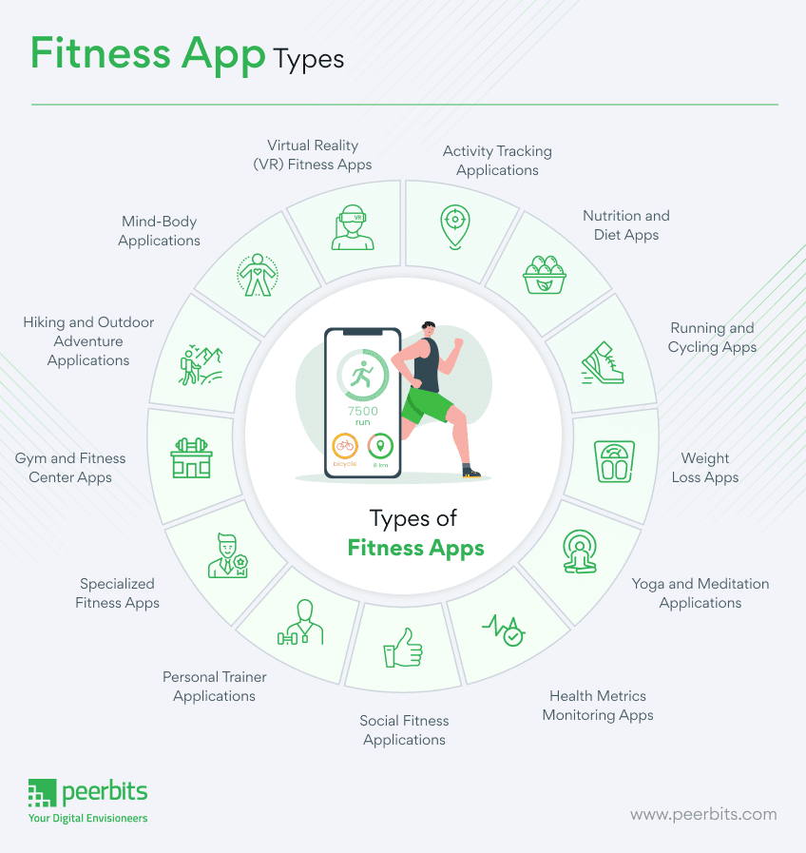

Figure 4: Fitness App Types.

**Activity Tracking: These apps utilize sensors in smartphones or wearable devices to monitor physical activities such as steps taken, distance covered, and calories burned. They provide users with real-time feedback on their activity levels and are exemplified by popular apps like Samsung Health** (‘Samsung Health’, 2023)**.**

**Workout and Exercise: Designed to cater to various fitness levels and goals, workout and exercise apps offer a wide range of routines and fitness plans. Users can choose from strength training, cardio workouts, yoga sessions, and more, depending on their preferences and objectives.**

**Nutrition and Diet: Nutrition and diet apps play a crucial role in helping users maintain a balanced diet and healthy eating habits. They enable users to track their calorie intake, plan meals, and receive nutritional guidance based on their dietary preferences and goals. Well-known examples include MyFitnessPal** (‘MyFitnessPal’, 2024) **and Lose It!** (‘Lose It!’, 2022).

**Running and Cycling: These apps are tailored specifically for runners and cyclists, offering features such as GPS tracking, route planning, and pace monitoring. Apps like Strava are popular among outdoor enthusiasts for their ability to track and analyse performance metrics during runs and rides** (‘Strava’, 2024).

**Health Metrics Monitoring: These apps integrate seamlessly with wearable devices like Fitbit** (‘Fitbit, 2024) **or Garmin Connect** (‘Garmin’, 2019) **to monitor various health metrics such as heart rate, blood pressure, and sleep patterns. They provide users with valuable insights into their overall health trends and help them make informed decisions about their well-being.**

**These categories encompass a diverse array of fitness app types that cater to different user needs and preferences. While the mentioned categories cover a broad spectrum of fitness and health-related activities, there are also specialized apps (**Figure 4**) available for specific activities or health goals, highlighting the ever-evolving nature of digital health and fitness technology.**

### Evolving Trends in Fitness and Health Tracking

**Wearable Technology: Leading fitness trackers and smartwatches, such as Fitbit and Apple Watch, utilize advanced sensors to monitor a range of health metrics, including heart rate, sleep patterns, and physical activity. These devices, equipped with GPS technology, can track outdoor activities, and measure additional factors like skin temperature and blood oxygen levels (‘Fitbit’, 2023).**

**Machine Learning and AI: My Fitness Pal employs a mobile app featuring Machine Learning (ML) algorithms for personalized workout and nutrition recommendations. Analysing users' workout history, biometric data, and relevant information allows the application to adapt and offer more effective, tailored suggestions (‘MyFitnessPal’, 2023).**

**Natural Language Processing (NLP): Virtual assistants like Apple’s Siri and Google Assistant utilize NLP technology to interpret and respond to voice commands, facilitating hands-free operation of fitness apps during workouts.**

**Computer Vision: In workout apps, Computer Vision technology ensures users maintain proper exercise form. By analysing video data, computer vision algorithms provide real-time feedback on exercise techniques, promoting correct form.**

## Effectiveness of Fitness Trackers

Wearable activity trackers have emerged as cost-effective tools to combat physical inactivity. A comprehensive review of 39 systematic reviews and meta-analyses, spanning diverse populations, demonstrated the positive impact of activity trackers on physical activity, body composition, and fitness, resulting in approximately 1800 extra steps per day, 40 additional minutes of walking, and about 1 kg reduction in bodyweight (Ferguson et al., 2022).

In a case study, the effectiveness of a wearable fitness tracker, specifically a Fitbit, was explored in a 36-week intervention program for an overweight, type 2 diabetic, geriatric subject. The integrated use of the Fitbit reported qualitative improvements in active minutes, steps taken, miles walked, calorie intake, sleep duration, and liquid consumption. The subject significantly increased daily walking distance from less than one mile to over 4.6 miles, nearing the recommended 5 miles per day goal. The technology facilitated continuous monitoring by the healthcare team, showcasing positive changes in exercise dedication and overall well-being (Thomas William Miller, 2017).

Figure 5: Variables measured over a 36-week study for Type 2 Diabetic patient using Fitbit (Thomas William Miller, 2017).

Moreover, another case study that involves a virtual fitness trainer app, assessed through the Situational Motivational Scale (SIMS) with 54 students, demonstrated effectiveness in motivating and engaging users in fitness activities. The app's virtual trainers positively influenced students' motivation, making the activities enjoyable and beneficial for their fitness levels. Respondents found the activities interesting, fun, and essential, highlighting the app's potential to enhance engagement and motivation in fitness-related endeavours (Mokmin and Nurullizam Jamiat, 2020).

In summary, the evidence suggests that wearable fitness trackers, exemplified by Fitbit and virtual trainer apps, play a crucial role in enhancing physical activity, motivating users, and positively impacting overall health and well-being.

## Understanding the Risks Associated with Fitness Trackers

Fitness tracker apps, with their extensive data collection and sharing capabilities, introduce significant privacy and security risks. A survey of 11,000 mobile health apps, representing 5,000 developers, reveals that fitness and nutrition apps are particularly advanced in sharing user data via shared application programming interfaces (APIs) (‘Permissions on Android’, 2024). Sharing commonly occurs with data aggregators like Apple’s HealthKit, wearables, and directly between apps (Grundy, Held and Bero, 2017).

These apps serve diverse functions, accessing vast amounts of highly personal data, including location, text messages, and even camera or photo access (Olmstead, 2015). The inherent access to personal health information heightens privacy risks, with concerns about data being shared with third parties, including advertisers and data brokers (Grundy, Held and Bero, 2017)

The risks extend to information leaks, manipulation, and loss, as demonstrated by Li's privacy threat model (Li, 2015). User profiling across multiple sites can lead to aggregated user profiles, monetized for marketing, or even exploited for identity fraud (Grundy, Held and Bero, 2017).

Mobile health apps, including fitness trackers, routinely request numerous permissions, indicating a broad spectrum of data access. The most common permissions relate to internet access, with implications for data transmission and sharing (Grundy, Held and Bero, 2017).

Common fitness tracker apps like Samsung Health and Fitbit apps have encountered challenges in usability and data privacy, which have been documented in various sources. Usability issues, including complex interfaces and inconsistent user experiences, missing features have been noted by reviewers and users alike (‘Appconner’, 2021), along with inaccuracy in collected data in certain apps.

Fitbit's data collection policy outlines that personal data collected through its app, including fitness and health-related information, is used primarily for providing and improving its services, such as personalized recommendations and analytics (‘Fitbit Legal: Privacy Policy’, 2023). Similarly, Samsung Health's data collection policy states that user data, including fitness, nutrition, and biometric information, is utilized for enhancing user experience, research, and product development (‘Samsung Privacy’, 2024).

Figure 6: Samsung Information Sharing Policy.

## Ethical Considerations

In developing the AFNT app, ethical considerations play a crucial role in ensuring user trust and data security. The app must prioritize data privacy by complying with GDPR (‘Overview of UK GDPR’, 2016) and implementing secure storage and transmission measures. Intellectual property rights are respected, necessitating proper licensing for third-party content. Accessibility is a key focus, with the app designed to be inclusive and user-friendly for individuals with disabilities following WCAG guidelines (WCAG 2, 2018). Security measures are implemented for the DBMS and ensure encrypted data transfer from the Arduino watch. Hardware standards for the Arduino watch prioritize user safety and comfort. Battery optimization features guarantee prolonged operation, and both the website and app adhere to accessibility standards and offer a user-friendly interface. Compatibility across various mobile platforms and seamless integration with mapping APIs further enhance the app's ethical usability and accessibility.

## Development Research Plan

Embarking on the AFNT Fitness Tracker development necessitates a thorough grasp of technical nuances in each project component. A comprehensive understanding of challenges, tasks, and effective management approaches is crucial. Due to the extensive nature of the AFNT project, it will be initially segmented into five planning stages, as outlined in Figure 7.

Figure 7: AFNT Initial Questions.

### Success Criteria

Figure 8: What I Need to Find Out.

After extensive research and consultations with supervisors, I've restructured the planning phase for AFNT into five key categories, as illustrated in Figure 9. The success criteria revolve around the development of a fully functional AFNT application compatible with both mobile and desktop platforms. It should adeptly track workouts, meals, and body data, and visualize body progress through graphs (Aiming to amalgamate multiple types of fitness apps into one, as depicted in Figure 4). Additionally, the Arduino watch should seamlessly connect and synchronize data with the AFNT app via Bluetooth, providing real-time heart rate, blood oxygen levels, and step count data.

### Technical Knowledge

To facilitate diagramming, I've opted for Astah UML for its versatility, ease of use, and popularity in industry (‘Powerful and Fast UML Diagramming Software - Astah’, 2023). Excel will be utilized for sprint, testing, and planning logs due to its spreadsheet functionality, ease of use and the wide range of planning templates it offers (‘Excel | Microsoft 365’, 2016).

The database architecture will be divided into two components: The Central Database Server (CDB) and the Local Database (LDB). In the LDB, all user personal data will be stored locally, ensuring that it remains exclusively accessible to the user. The database will be created using SQLite, a highly popular and easy to use database modelling tool (‘SQLite’, 2024). This approach aligns with AFNT's commitment to maintaining the security and privacy of user data. Conversely, the CDB will house predefined workouts, meals, and user login credentials, facilitating secure login and access to AFNT's user data. CDB will be stored in a MySQL server due to its reliability, scalability, performance, security features, cross-platform compatibility, and strong community support, making it suitable for various applications (‘SQL Server | Microsoft’, 2022).

For the AM Website, Python Flask was chosen for its simplicity and widespread use in the industry (‘Flask Documentation (3.0.x)’, 2024). Extensive online resources are available to support effective implementation. In developing the AFNT application and Graphical User Interface (GUI), Python programming language and the Kivy GUI Framework was used as it offers flexibility and cross-platform support, making it an ideal choice. It's open-source and user-friendly (‘Kivy: Cross-platform Python Framework for NUI’, 2024).

Regarding the Arduino Fitness Watch, components from Tiny Circuits were selected for their compact design and ease of assembly, resembling modular electronic components akin to Lego blocks (‘TinyCircuits - Maker of Tiny, Open-Source Electronics’, 2024). Tiny Circuits also boasts a supportive community and provides comprehensive documentation and basic examples to aid development (‘Tiny Circuit Projects’, 2022). All components were acquired at personal expense.

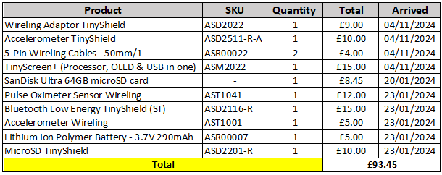

Figure 9: Arduino Watch Components.

Figure 10: Assembly of All Arduino Watch Modules

Figure 11: First Version of Arduino Watch Interface (24/01/2024).

### AFNT Evaluation Criteria

In this study, we will evaluate two widely used fitness tracker apps, Samsung Health, and Fitbit, based on their performance and features, as illustrated in Figure 9. AFNT stands out from Samsung Health (Paired with Samsung Galaxy Watch 1) and Fitbit app (Paired with Fitbit Flex 2) in several aspects:

Figure 12: AFNT and Arduino Watch Evaluation Table.

**Selection Rationale for Samsung Galaxy Watch and Fitbit Flex 2**: The Samsung Galaxy Watch and Fitbit Flex 2 were chosen for practical reasons, based on my prior experience with the Samsung Galaxy Watch, which enables thorough testing of both devices. Moreover, the Fitbit Flex 2 was selected due to its fitness-focused design akin to the Arduino Watch, distinguishing it from multipurpose/flagship smartwatches like the Apple Watch or higher-end Samsung models. Its core features centre on tracking activities such as steps, distance, calories, and sleep patterns, with limited smartwatch functionalities such as call and text notifications. Moreover, Including the original Galaxy Watch allows for a comparison of the Arduino watch's capabilities against a more advanced smartwatch in terms of both hardware and software, while cost considerations also influenced the selection process.

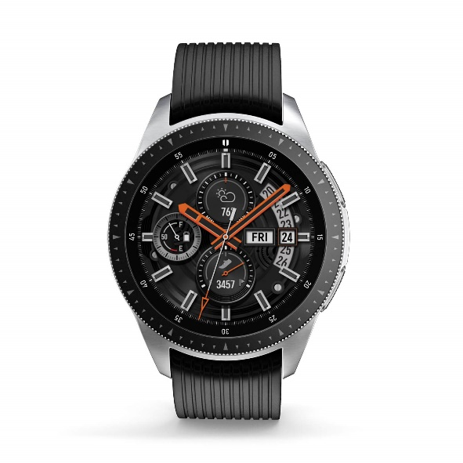

Figure 13: Samsung Galaxy Watch (2018).

Figure 14: Fitbit Flex 2 (2016).

**Privacy Measures**: AFNT emphasizes data privacy by storing user data locally on the device (LDB), ensuring that personal information is not utilized for marketing, advertisement, or analytical purposes as AFNT has no way to access this data. It also incorporates a feedback mechanism for users to share data securely, a feature less emphasized in Samsung Health and Fitbit apps.

**Cross-Platform Functionality**: AFNT is designed to function seamlessly across both mobile and desktop platforms, providing users with flexibility in accessing their fitness and health data. This versatility contrasts with the mobile-centric approach of Samsung Health and Fitbit apps.

**Customizable Workout Plans**: Unlike Samsung Health and Fitbit apps, AFNT allows users to tailor and customize their workout plans according to their specific fitness objectives and preferences, fostering greater user engagement and motivation.

**Enhanced User Control**: AFNT offers users extensive control over their fitness, health, and nutrition data. Users can modify nutritional details of food items, rate workouts, customize exercise aspects, allocate workouts and meals, and manage data synchronization across devices. This level of control enhances the user experience and personalization, surpassing what is currently offered by Samsung Health and Fitbit apps.

### Requirements Gathering

The app aims to provide a seamless user experience with features like customizable workout plans, nutritional tracking, and real-time health data from the Arduino watch. User-friendly interfaces, security measures, and cross-platform compatibility are fundamental requirements. These requirements were gathered in the following ways:

* Regularly consulting mentors like Martin Serpell and Eman Qaddoumi for industry insights and best practices in fitness app development.
* Analysing UI, features, and functionalities of popular fitness apps like Samsung Health and Fitbit to guide AFNT app design decisions.
* Tracking personal fitness progress at the gym and understanding user expectations firsthand (Figure 15, Figure 16 and Figure 17).
* Conducting comprehensive online research to stay abreast of emerging trends and user demands in fitness app development.

Figure 15: My Personal Workout Tracking Method Using Excel Spreadsheet.

Figure 16: My Personal Workout Data Using Excel – 2023

Figure 17: My Workout Progress Evaluation – 2023

# Requirements

An essential aspect crucial to the success of any project lies in defining a comprehensive set of requirements. These requirements serve as concise outlines detailing the project's objectives and the expected performance of its deliverables. They can encompass both broad and specific descriptions of the system's behaviour and functionality.

In refining the final list of requirements, careful consideration was given to attributes such as traceability, testability, and consistency. Some requirements may represent distinct functionalities, contingent upon the completion of others, and they are noted for their dependencies. The subsequent sections will delineate the structured format of the requirements, categorizing them into non-functional and functional requirements. Additionally, a use case diagram, use case descriptions, class diagrams and the projects overall architecture diagram will be presented.

**Note**: For the complete list of project objectives, use case diagrams with descriptions, and requirements, please refer to the Requirements file provided under /Documents/Reports Directory.

## Requirement Structure

The requirement structure is specifically crafted to ensure clarity and facilitate efficient tracing and testing of project objectives or requirements. The requirement code follows a well-defined format as outlined below:

<***Requirement/Objective***><***Phase Component***><***Number***>

### Requirement/Objective:

This component indicates whether the property is a **functional** requirement ('F'), a **non-functional** requirement ('NF'), or an overall project **objective** ('O').

### Phase Component:

It signifies the specific phase of the project to which the requirement or objective pertains. Each phase is represented by a distinct code, such as 'A' for **App** development, 'D' for **Database**, or 'AW' for **Arduino Watch** development.

### Number:

Used to differentiate between cases with the same requirement or objective and phase. It ensures unique identification within a specific phase and requirement/objective category.

For instance, adding meals and workouts are both functional requirements for the app development phase of the AFNT App. Despite being similar, they are assigned different numbers to distinguish them from each other effectively.

The table below succinctly summarizes all the codes and their meanings for easy reference and streamlined project management. The table below displays all the codes and their meanings for simplicity and easy reference.

Table 1: Requirement/Objective Abbreviations.

|  |  |
| --- | --- |
| **Requirement/ Objective** | |
| O | Objective |
| F | Functional Requirement |
| NF | Non-Functional Requirement |

Table 2: Phase Component Abbreviations.

|  |  |
| --- | --- |
| **Phase Component** | |
| A | AFNT Application |
| AW | Arduino Watch |
| D | Database |
| DBR | Data Backup & Recovery |
| DS | Data Storage & Optimization |
| ES | Efficiency & Sustainability |
| P | Performance |
| PS | Privacy & Security |
| R | Reliability |
| TPS | Third Party Service Integration |
| U | Usability |
| W | Admin Management Website |

## Requirement Categorization

The project's requirements are distributed across various phases, with each requirement accompanied by a concise description of its purpose. Additionally, each requirement is prioritized using the MoSCoW prioritization technique (Agile Business, 2022), which enables effective planning and management throughout the project lifecycle. MoSCoW prioritization was selected for its simplicity and suitability for both pre-planning and post-planning stages.

Furthermore, each requirement is tagged with a completion status to facilitate straightforward tracking of progress. Additionally, the date of creation or last update is recorded for each requirement, providing valuable insights into the project’s development over time.

Table 3: MoSCow Prioritization table.

|  |  |  |
| --- | --- | --- |
| **Priority Level** | **Abbreviation** | **Meaning** |
| Must have | M | Task that is crucial for the project. |
| Should have | S | Important task but not vital for the final project. |
| Could have | C | Wanted or desirable but not important for the project’s overall goal. |
| Won’t have | W | Out of scope. |

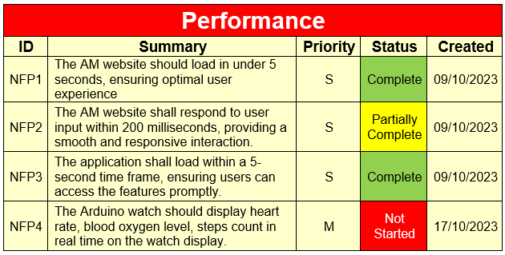

Figure 18: Requirement Table Overview.

**Note**: For further reading on project aims, objectives, and requirements, please navigate to Appendix A: Requirements.

## Usecase Diagrams and Descriptions

An effective strategy for informing and crafting a set of requirements is through the creation of a use case-driven system. Use cases offer detailed insights into how the system will be utilized, encompassing information about users, usage scenarios, and the sequences and structures inherent in its functioning. The use of UML diagrams is prevalent in this context, as they are widely recognized as an industry standard. Many software developers rely on UML diagrams to articulate software design models, making familiarity with them a common expectation among software professionals (Alam, 2022).

For this project, three UML use case diagrams have been developed, each corresponding to a different aspect of the project: one for the AFNT Application, one for the Arduino Watch, and one for the Admin Management Website. These diagrams are designed to align with the project's requirements and objectives. Given the complexity of each diagram, detailed descriptions of the use cases have been provided to offer a deeper understanding, particularly for less detailed use cases. Additionally, certain use case descriptions encompass multiple related use cases to streamline the presentation. For instance, the "Manage workouts" use case may include sub-use cases such as "Add Workout," "Edit Workout," and "Delete Workouts," which are combined into a single use case description for clarity and simplicity.

### Usecase Diagrams and Descriptions

Figure 19: Usecase Admin Management Website.

Table 4: Admin Management Website Usecase description.

Figure 20: Arduino Watch Usecase Diagram.

Table 5: Store Measured Data and the <<extend>> Usecase description.

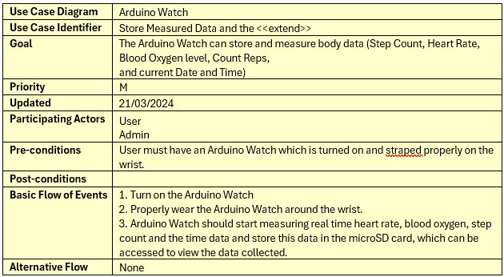

Table 6: Sync Watch Data to Application Usecase description.

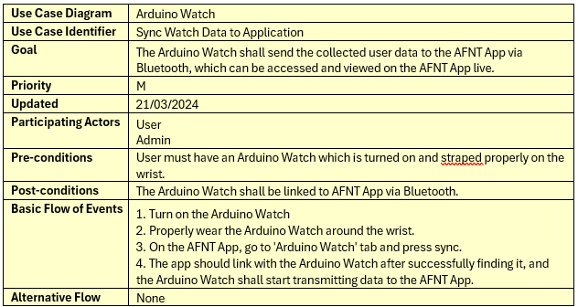

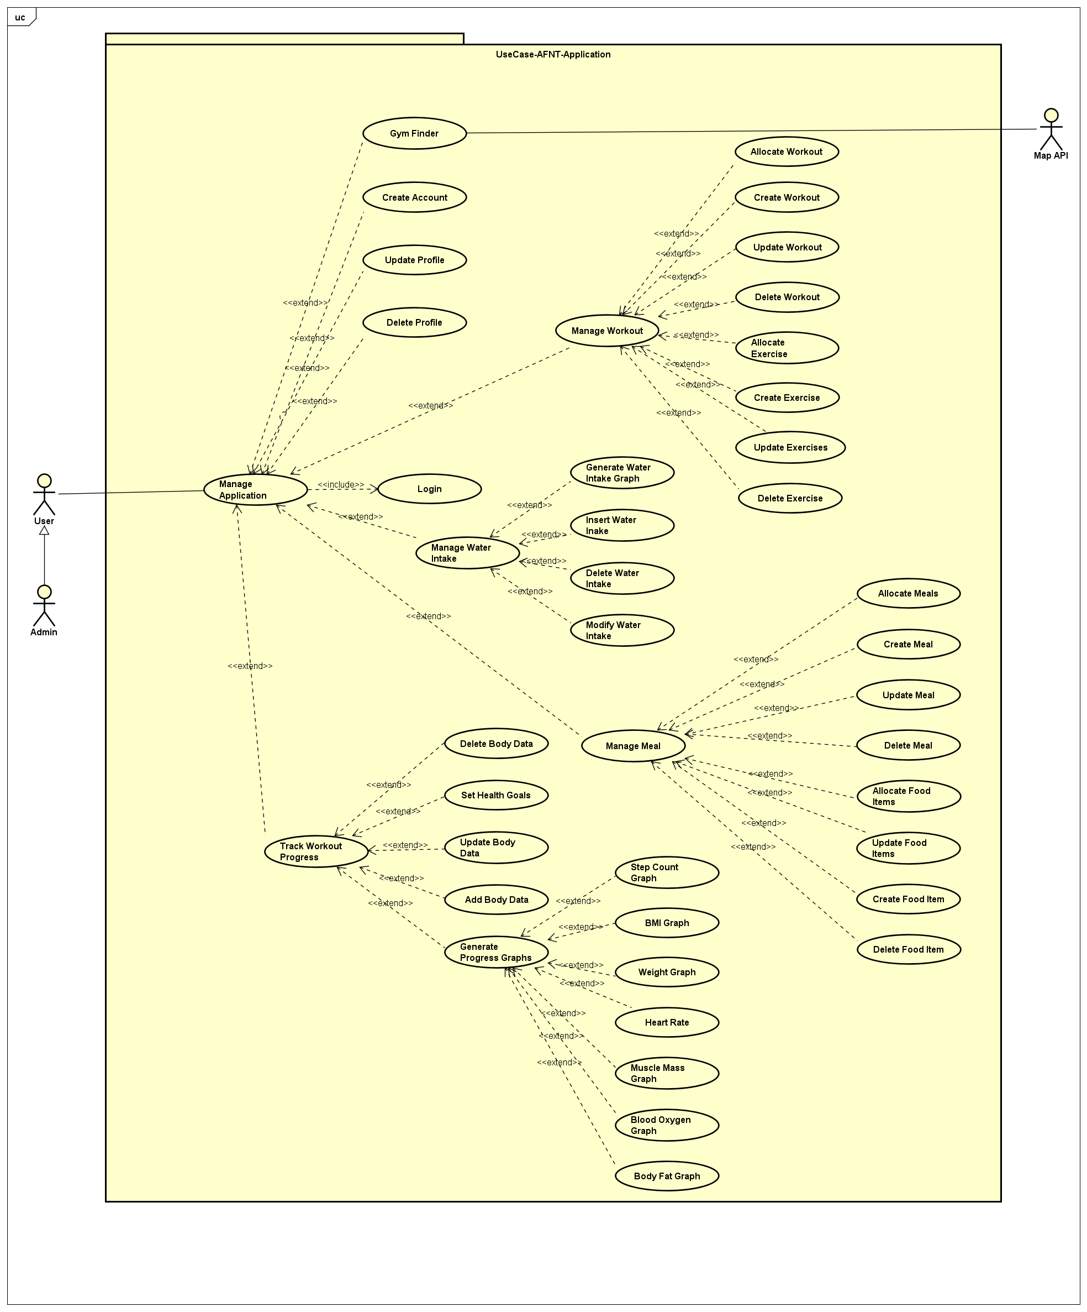

Figure 21: AFNT App Usecase Diagram.

Table 7: Manage Workout and the <<extend>> Usecase description.

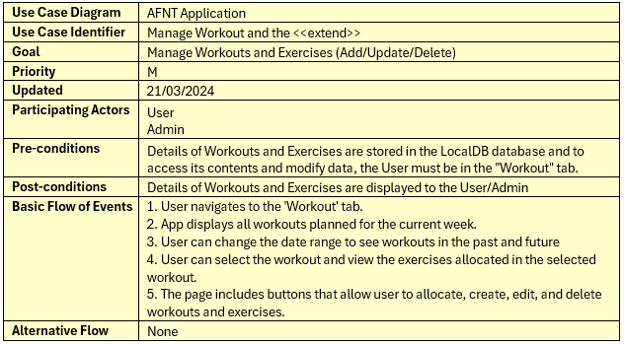

Table 8: Manage Meal and the <<extend>> Usecase description.

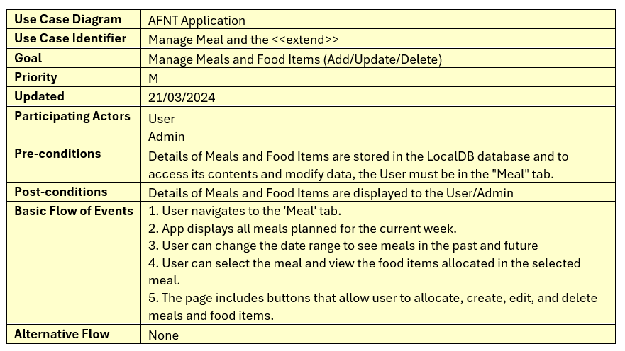

Table 9: Manage Water Intake and the <<extend>> Usecase description.

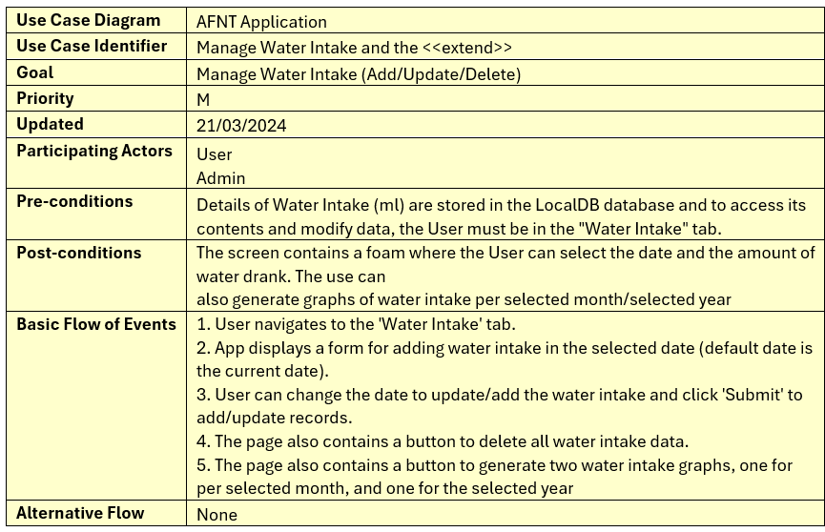

Table 10: Gym Finder Usecase description.

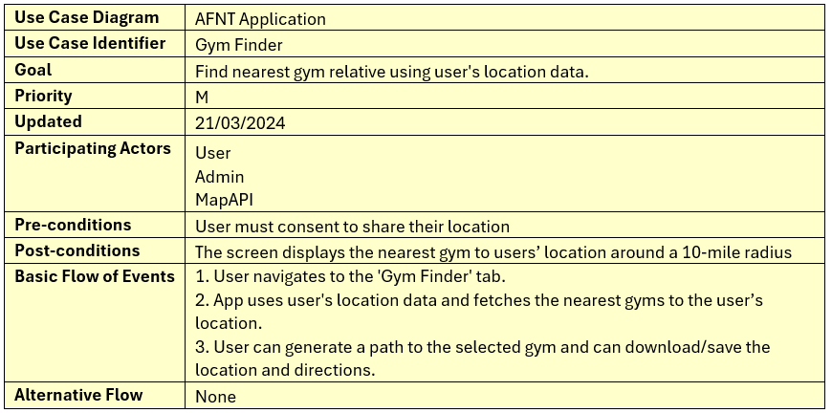

Table 11: Create Account Usecase description.

Table 12: Update Profile Usecase description.

Table 13: Delete Profile Usecase description.

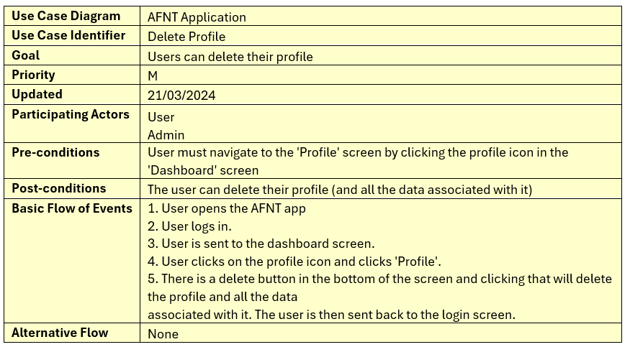

Table 14: Track Workout Progress and the <<extend>>

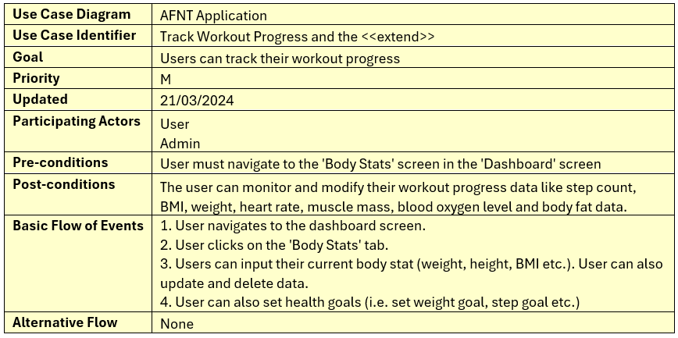

Table 15: Generate Progress Graph and the <<extend>> Usecase description.

In conclusion, the Requirements chapter provides a comprehensive overview of AFNT project's objectives, functionalities, and performance expectations. By adhering to a structured format and utilizing prioritization techniques, the requirements are organized and categorized to facilitate efficient project management. The inclusion of use case diagrams and descriptions further enhances understanding and alignment with project goals. Overall, this chapter serves as a crucial reference point for understanding AFNT’s key goals and objectives.

# Methodology

In the methodology chapter, we will explore how agile principles and the Trello Kanban methodology were utilized in the AFNT project to ensure smooth development and delivery. The chapter will discuss the rationale behind selecting Trello as the project management tool and highlight the benefits of employing Kanban for project execution. It will outline the key phases of the AFNT app development and describe the division of the project into sprints, focusing on each sprint's objectives.

Additionally, the chapter will delve into the integration of Trello Kanban into the project, explaining the structure of the Kanban board and its role in organizing and tracking tasks. Lastly, it will discuss the advantages of using Trello Kanban, emphasizing its simplicity, scalability, transparency, and customization capabilities. Through these insights, the methodology chapter will provide a comprehensive understanding of the strategies and tools utilized in the AFNT project for effective project management.

## AFNT Phases

Key Phases of AFNT App Development:

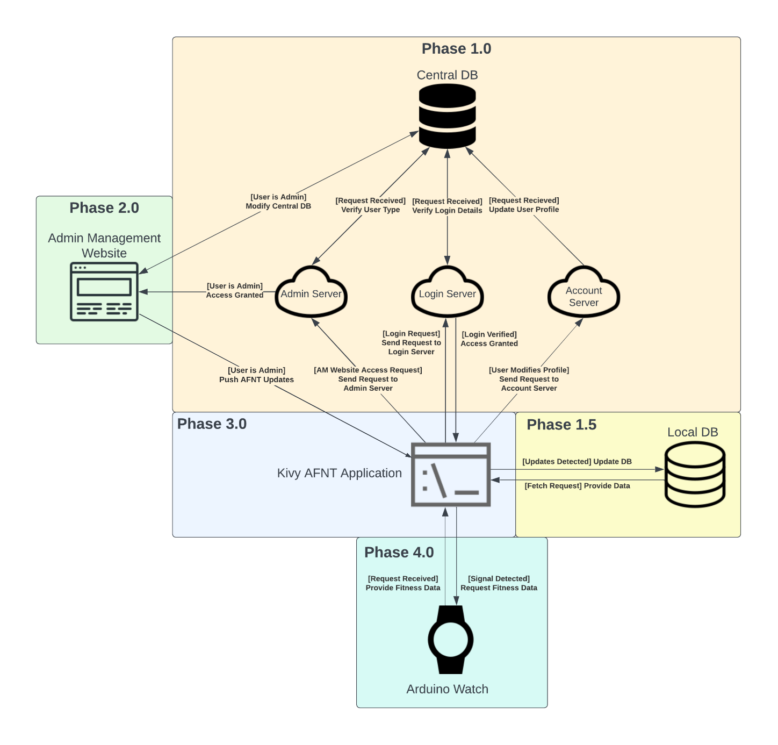

Figure 22: AFNT Project Phases.

The AFNT project is divided into four key phases:

Table 16: AFNT Phase Descriptions.

|  |  |
| --- | --- |
| Phase 1 | Phase 1 involves setting up the Central Database (CDB) within the Database Management System (DBMS). The CDB stores predefined workouts, meals, and user login credentials securely. Updates made in the CDB are synced to the user's Local Database (LDB) upon successful login. |
| Phase 1.5 | The LDB is introduced to store user-specific workout, meal, and body statistics data locally. This data remains unaffected by updates from the CDB, ensuring user customization is preserved. |
| Phase 2 | introduces the Admin Management Website (AM), allowing administrators to manage the CDB and push updates to the AFNT application. |
| Phase 3 | focuses on developing the AFNT application, enabling users to track workouts, meals, and body data. Users can also modify their profiles, with changes reflected in the CDB. |
| Phase 4 | Phase 4 extends Phase 3 by introducing the Arduino Fitness Watch, capable of monitoring health metrics and seamlessly transferring data to the AFNT application via Bluetooth or a wired connection. |

## Sprint Planning

Sprint planning is a crucial aspect of project management, especially in agile methodologies like the one employed in the AFNT Project. It involves breaking down the project into smaller, manageable chunks known as sprints, each focusing on specific objectives.

In the case of the AFNT Project, sprint planning has resulted in the division of the project into four distinct sprints, with each sprint dedicated to a particular phase of development. However, it's important to note that due to time constraints and priority considerations, Phase 2 of the project will be largely disregarded. Below are the details of each sprint and its corresponding focus:

Table 17: Sprint 1 – Planning & Design.

Table 18: Sprint 2 – Phase 1 Implementation & PIP

Table 19: Sprint 3 – Phase 3 Implementation.

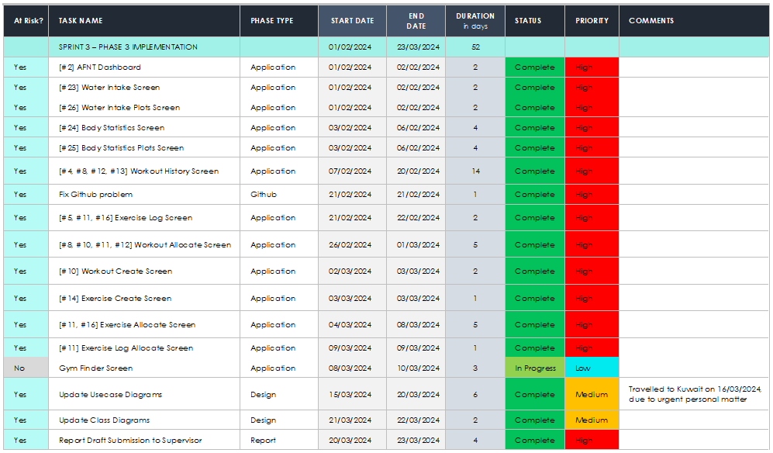

Table 20: Sprint 4 – Phase 4 Implementation.

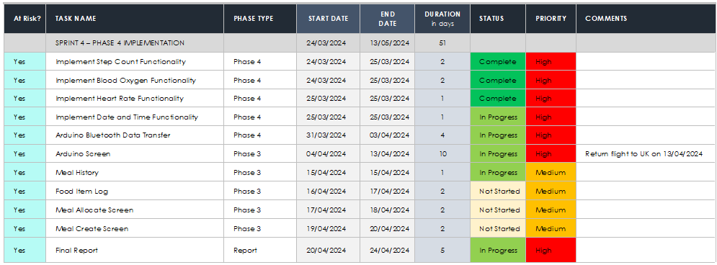

## Gnatt Chart

Figure 23: Gnatt Chart.

## Trello Kanban Integration

Trello was chosen as the project management tool for its alignment with agile principles and its user-friendly interface, facilitating seamless tracking of tasks, progress, and priorities (Atlassian, 2019). This chapter explores the benefits of Trello Kanban methodology, its incorporation into the AFNT project, and its pivotal role in managing the project's advancement. Additionally, it outlines the essential phases of AFNT app development, providing an in-depth overview of the project's progression. Through the integration of agile methodologies, well-structured project phases, and proficient utilization of Trello Kanban, the AFNT project demonstrates a systematic and organized approach to software development.

Figure 24: AFNT Project Kanban Board.

Figure 25: Project Labels on Trello.

To access Trello dump data please navigate to <<>>

The Kanban methodology operates on the fundamental principle of visualizing tasks and workflow on a board. This board is typically divided into columns representing different stages of the project. Each task or "card" progresses through these columns from initiation to completion. Trello, as a Kanban tool, provides a digital platform for teams to create boards, lists, and cards, facilitating collaboration and transparency in project management. Cards can be assigned to team members, labelled with priorities, and updated in real-time as progress is made.

In the case of the AFNT project, the Trello Kanban board consists of eight main columns with four columns specifically allocated to each sprint, as outlined in section ‎4.2 each serving a specific purpose:

Table 21: Trello Kanban Column Descriptions.

|  |  |
| --- | --- |
| PROJECT – RESOURCES | This column serves as a repository for all relevant and useful information, making it easy and convenient to access upcoming submission deadlines or supervisor meetings. It provides a centralized location for important project-related resources. |
| TO – DO | Tasks that have not yet been started or completed are placed in this column. It serves as a backlog of pending tasks that need to be addressed. |
| IN – PROGRESS | Tasks that are currently being worked on or are partially implemented are moved to this column. |
| SPRINT 1 – PLANNING & DESIGN | Once design/planning tasks are fully confirmed and planned, they are moved to this column. It signifies that the planning and design phase for these tasks is complete, and they are ready for implementation. |
| SPRINT 2 – PHASE 1 IMPLEMENTATION & PIP | This column is dedicated to Phase 1 (Database and Server) implementation. Including the submissions, deadlines, and demos related to the Project-In-Progress (PIP) session. |
| SPRINT 3 – PHASE 3 IMPLEMENTATION | Tasks that have been fully implemented from the AFNT app are moved to this column. It indicates that the implementation phase of these tasks is complete, and they are ready for testing or review. |
| SPRINT 4 – PHASE 4 IMPLEMENTATION | Tasks related to the Arduino watch development (Phase 4), final project submissions and demos, particularly those associated with the final deadline, are placed in this column. It ensures that all final deliverables are organized and accounted for as the project nears completion. |
| SUPERVISOR – MEETINGS | Important dates and details regarding supervisor meetings are noted in this column. |

By utilizing these specific columns, the Trello Kanban board effectively organizes and tracks the progress of tasks throughout the project lifecycle, ensuring clarity, accountability, and efficiency in project management.

## Trello Kanban Advantages

The decision to utilize Trello Kanban for the AFNT app was based on several factors:

Table 22: Trello Kanban Advantages.

|  |  |
| --- | --- |
| Simplicity | Trello's user-friendly interface and intuitive design make it easy for team members to adopt and use effectively, without extensive training. |
| Scalability | Trello is highly scalable and can accommodate projects of various sizes and complexities. As the AFNT app project evolved, Trello could easily adapt to changing needs and requirements. |
| Transparency | Kanban methodology promotes transparency by providing visibility into the status of tasks and progress made. This transparency enhances accountability and ensures everyone is on the same page. |
| Customization | Trello allows for customization to fit the specific needs and preferences of the team. Boards, lists, and cards can be tailored to reflect the unique workflow and requirements of the AFNT app project. |

The integration of Trello Kanban into the AFNT project offered an organized and effective project management strategy that aligned seamlessly with the adopted agile methodology. By leveraging Kanban boards and Trello's user-friendly interface, the project could visualize tasks, monitor progress, and prioritize activities with ease. The project's division into four distinct phases, each playing a vital role in the AFNT app's development, facilitated a structured approach, ensuring clarity and focus on every stage.

Moreover, the incorporation of use case and requirements gathering laid a solid framework for project design, aiding in the creation of wireframes and class diagrams, which will be further explored in the Design chapter. Collectively, these elements, alongside Trello Kanban, agile methodology, and phased development, established a strong foundation for the successful implementation of the AFNT project.

# Design

**Incomplete**

As previously outlined, the AFNT project is structured into four distinct phases, each addressing crucial elements of the project's development. This chapter delves deeper into each phase, providing a comprehensive overview of its structure and objectives.

**Note**: To access all the design files (i.e. usecase, class, wireframes etc.). Please navigate to **https://github.com/alisuhail-amanu2/AFNT/tree/main/Documents/Design**

## Phase 1: Database Design

Phase 1 focuses on establishing a Database Management System (DBMS) featuring a Central Database (CDB). The CDB is primarily tasked with storing predefined workouts, meals, and user login credentials to ensure secure access. Operating as a SQL Database Server, the CDB is exclusively accessible to administrators. Updates made to the CDB are synchronized with the user's Local Database (LDB) upon successful user login. It's important to note that the Central Database solely manages predefined workouts and meals provided to users by default and does not store any user-specific workout or meal data. Custom workouts and meals created by users remain unaffected by changes pushed from the CDB.

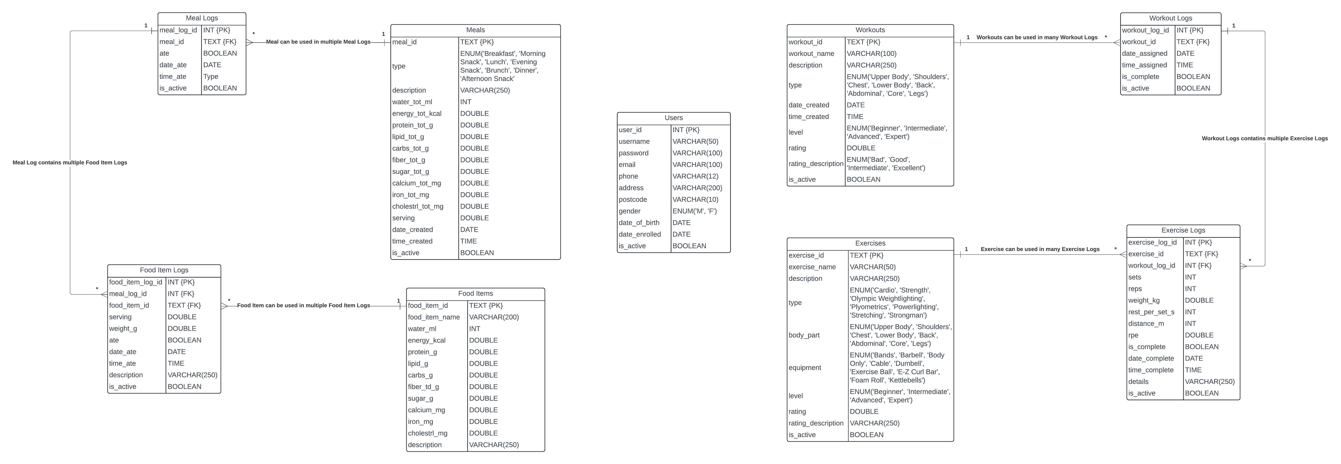

Figure 26: Central Database Schema.

Table 23: Central and Local Database Schema Descriptions.

|  |  |
| --- | --- |
| Table Name | Description |
| Workouts | Workouts Contains details of various workouts, such as the workout name and type. For instance, a workout might be categorized as "legs." |
| Workout Logs | Stores records of individual workout sessions created using the definitions from the Workouts table. This allows for the creation of different workout logs based on the definitions provided. For example, the workout ‘legs’ can be allocated by user on any day of the week, and once the workout is completed, the user can set the completion status as “complete”. |
| Exercises | Holds definitions for various exercises, with each exercise being associated with a specific workout. For example, the exercise "barbell squats" can be allocated to the "legs" workout. This dataset was imported from Kaggle (Pandit, 2022). |
| Exercise Logs | Exercise Log: Records detailed information for each exercise, including the number of sets, repetitions, and rest periods. This data corresponds to exercises defined in the Exercises table and assigned to specific workouts. For instance, the "barbell squats" exercise may be designated for the "legs" workout, with specifications such as 3 sets of 10 repetitions and a 90-second rest period between sets. |
| Meals | Meals Contains definitions for different meal types, such as "Joe's breakfast," categorized by meal type (e.g., breakfast). This data was imported from Kaggle (vinitshah0110, 2022). |
| Meal Logs | Utilizes meal definitions from the Meals table for allocation purposes. Users can select meals from this table and allocate them to specific dates, creating new meal logs. For example, “Joe’s breakfast” can be allocated on 16th March 2024 and the user can set the meal status as “complete.” |
| Food Items | Stores definitions and nutritional information for various food items. For instance, "egg" is a food item, and its nutritional contents are recorded in this table. |
| Food Item Logs | Allow users to allocate food items from the Food Items table to meals and specify serving sizes or quantities. For example, users can add the food item "egg" and adjust the serving size as needed. |
| Users | Stores personal information for each user, including username, encrypted password, gender, address, and contact details. Gender information is used for recommending workouts and meals tailored to the user's gender, address data helps in locating nearby gyms, and contact details are utilized for verification and two-factor authentication (currently out of scope). |

It's important to note that the deletion of any preset meal or workout does not impact existing meal or workout logs. Rather than removing the record entirely from the database, the system updates the "is_active" column of the record to 0, indicating that it is no longer active. As a result, users will no longer be able to view or access this record, but the associated logs will remain intact in the database.

### Local Database

Phase 1.5 expands the Database design by introducing the Local Database (LDB), dedicated to storing user-specific workout, meal, and body statistics data. Unlike the Central Database (CDB), LDB stores data locally, accessible only to the respective user. Utilizing SQLite, LDB comprehensively captures all user-related information, ensuring privacy and security.

Upon user login, any updates made in the Central Database are seamlessly synchronized with LDB, ensuring that users have access to the latest predefined meals and workout data. However, these updates do not impact user-specific custom workouts and meals, preserving their integrity. Even past user entries remain unaffected by CDB updates.

Furthermore, while both CDB and LDB share the same schema for fundamental components such as users, workouts, exercises, meals, and food items, LDB includes additional tables specifically tailored for collecting and managing body data. These tables will be elaborated in this section.

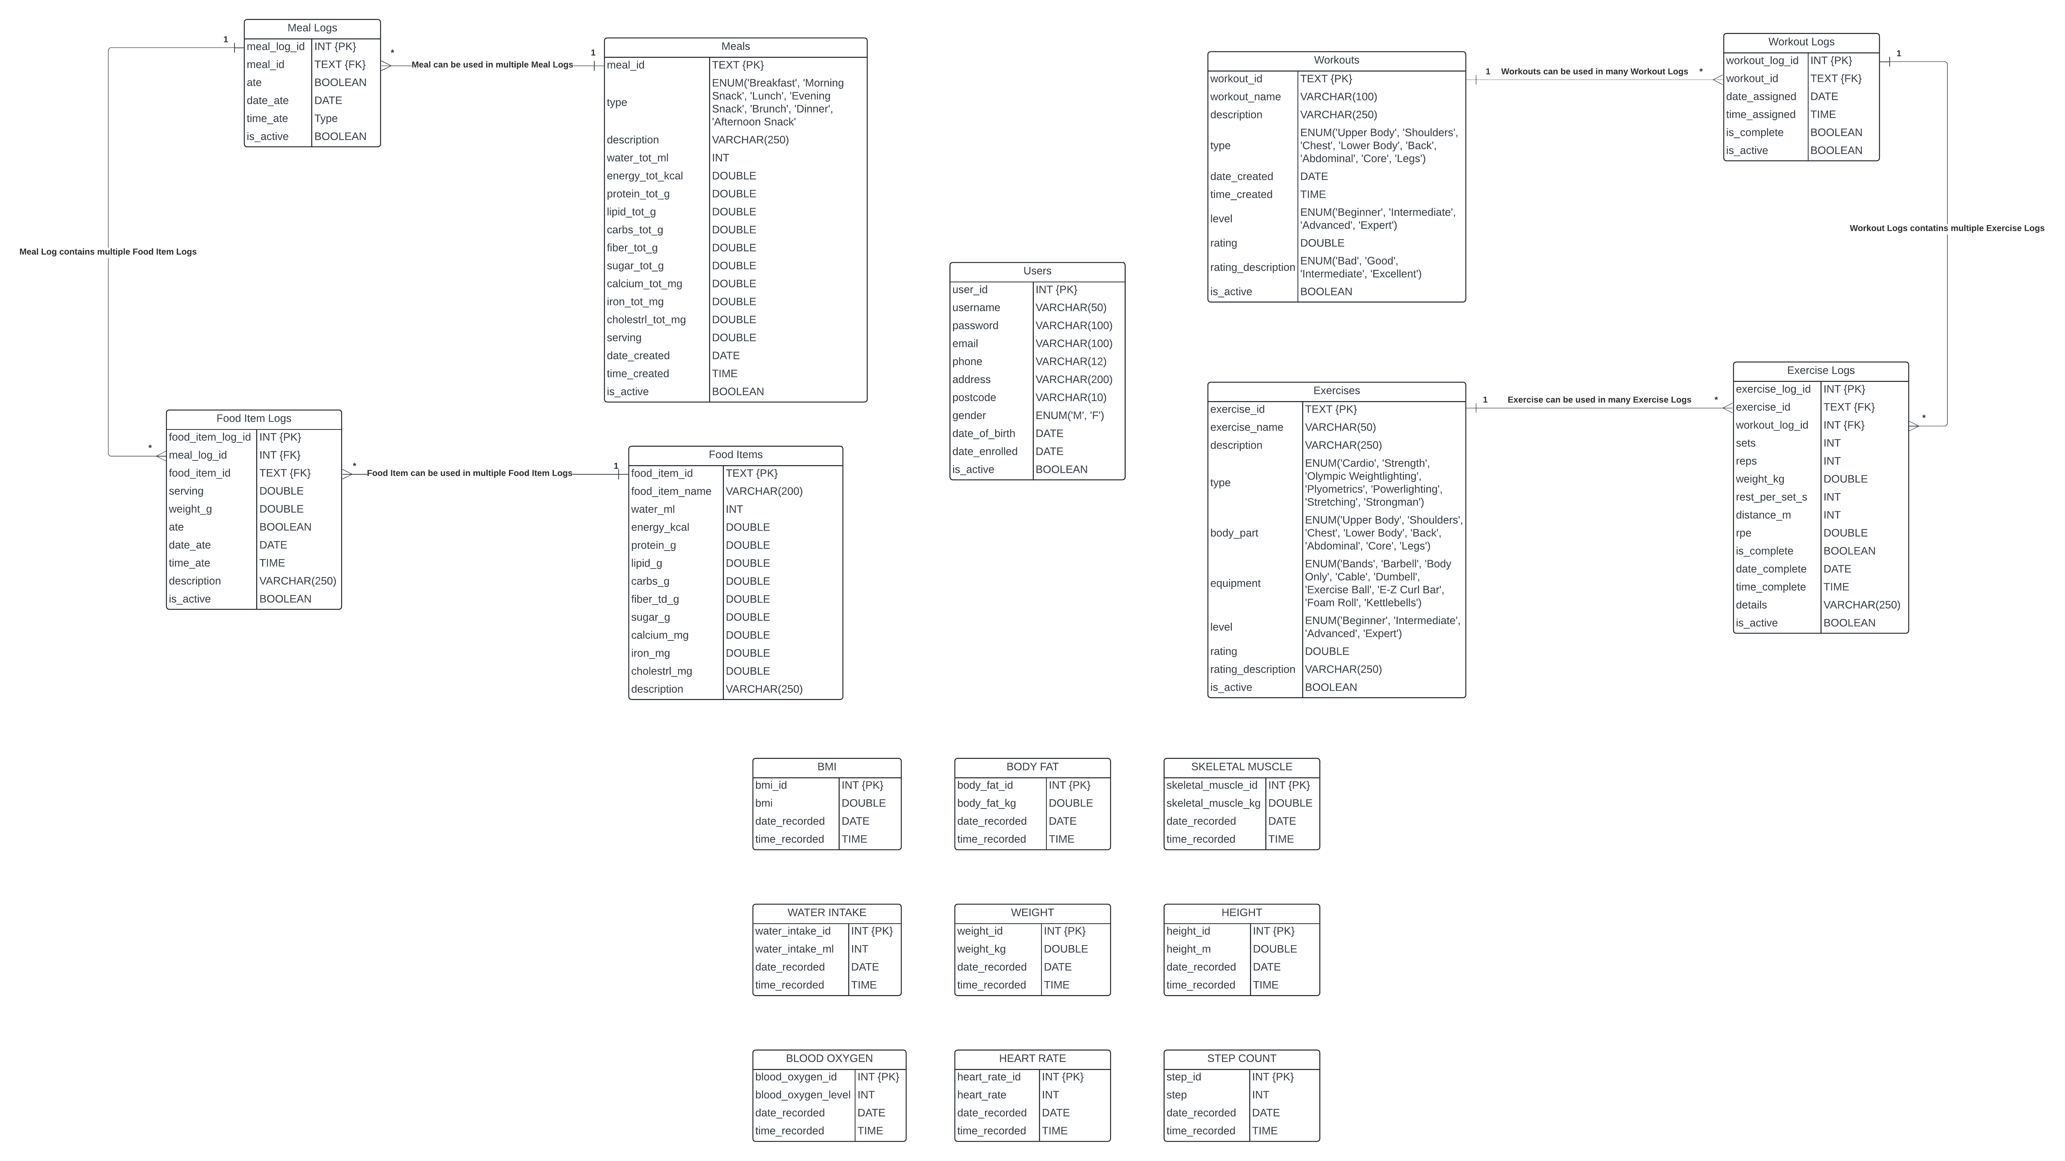

Figure 27: Local Database Schema.

Table 24: Local Database Schema Descriptions.

|  |  |  |
| --- | --- | --- |
| Table Name | Collection Method | Description |
| BMI | User Input or Automatically calculated based on provided weight and height data. | Stores BMI data and the date/time of the record creation. It is calculated using the formula (‘BMI Calculator’, 2024): round(weight / ((height/100) * (height/100), 1) |
| Body Fat | User Input or Automatically calculated based on the provided age and gender data. | Stores Body Fat data and the date/time of the record creation. It is calculated using the formula (‘Body Fat Calculator’, 2017): **Males**: round(1.20 * bmi) + 0.23 * age - 16.2, 1) **Females**: round(1.20 * bmi) + 0.23 * age - 5.4, 1) |
| Skeletal Muscle | User Input | Stores Skeletal Muscle (Muscle Mass) and the date/time recorded. |
| Water Intake | User Input | Stores the water intake in millilitres (ml) and the date/time recorded. |
| Weight | User Input | Stores the weight in kilograms (kg) and the date/time recorded. |
| Height | User Input | Stores the height in metres (m) and the date/time recorded. |
| Blood Oxygen Level | Arduino Watch (Pulse Oximeter Sensor) | Stores the blood oxygen in percentage (%) and the date/time recorded. |
| Heart Rate | Arduino Watch (Pulse Oximeter Sensor) | Stores the Heart Rate data in beats per minute (bpm) and the date/time recorded. This data will collected using the Arduino Watch’s Pulse Oximeter Sensor. |
| Step Count | Arduino Watch (Accelerometer) and User Input | Stores the step count of user per day and the date recorded. This data can be collected using the Arduino Watch. |

### Servers

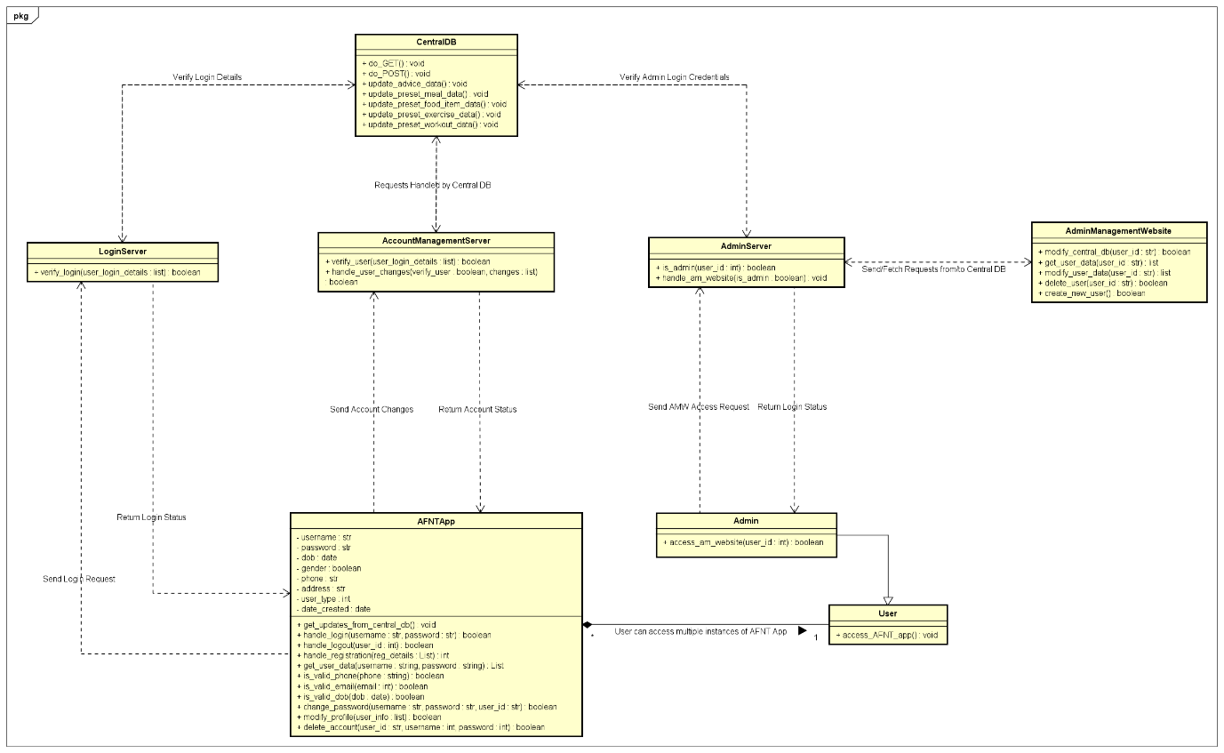

Figure 28: Central Database and Admin Website Class Diagram.

Table 25: Database Server Descriptions.

|  |  |
| --- | --- |
| **Class** | **Description** |
| LoginServer | Responsible for authenticating user login credentials within the AFNT app. |
| AccountManagementServer | Manages user profile and personal details, facilitating any necessary updates or modifications. |
| AdminManagementServer | Validates admin login credentials and facilitates database changes to the Central Database (CDB). |

## Phase 2: Admin Management Website Design

Figure 29: Admin Management Website Usecase Diagram.

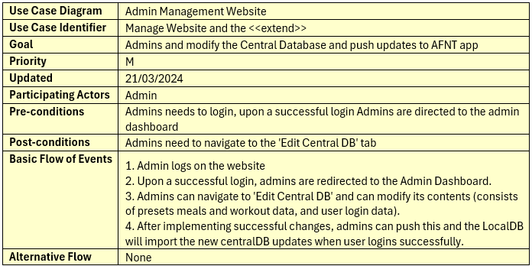

Table 26: Admin Management Website Usecase Description.

Phase 2 introduces the Admin Management Website (AM), which serves as the centralized platform for administering the Central Database (CDB) and facilitating updates to the AFNT application. This web-based interface is exclusively accessible to administrators, empowering them to manage and modify CDB content effectively. To gain access to the AM website, Admins will have to sign in, and the login details will be validated using the Admin Management server that securely communicates with the CDB. After login details are successfully validated, they can access the AM website.

### Admin Management Website Wireframes

Figure 30: Admin Management Website Wireframes.

<https://github.com/alisuhail-amanu2/AFNT/tree/main/Documents/Design/UI_Sketches/AFNT_Application>

## Phase 3: AFNT Application Design

Phase 3 of the AFNT project focuses on developing the AFNT application, which aims to provide users with a comprehensive set of features for tracking workouts, managing meals, and monitoring body data. This section will explore three key aspects of the application's design: wireframes exploration, application structure using the Kivy GUI framework, and class definitions.

Wireframes will outline the visual layout and user interface elements, while the application's architecture implemented with Kivy GUI will ensure a dynamic and responsive user experience. Finally, class definitions will encapsulate data and behaviour into reusable components, contributing to the application's functionality and modular design. Together, these components will provide insights into the AFNT application's design and implementation process.

**Workout Data:** Workout data encompasses all workout logs/sessions generated by users, including custom workouts and associated exercise logs. Each workout log is linked to specific exercises defined within custom workouts.

**Meal Data:** Meal data includes all meal logs/sessions created by users, covering custom meals and associated food item logs. Each meal log is associated with specific food items defined within custom meals.

**Body Statistics Data:** Body statistics data captures performance, growth, and progress metrics vital for users to track their fitness goals. Key metrics initially focused on by AFNT include Step Count, BMI, Body Fat, Skeletal Muscle, Heart Rate, and Blood Oxygen Level.

### AFNT Application Wireframes

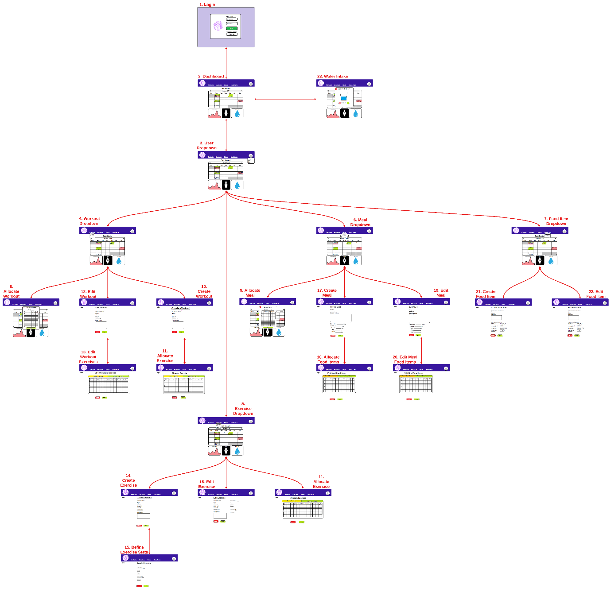

Table 27: AFNT App Wireframes.

<https://github.com/alisuhail-amanu2/AFNT/tree/main/Documents/Design/UI_Sketches/AM_Website>

Wireframes played a crucial role in the development of the AFNT application by providing a visual representation of its layout and structure. These skeletal outlines serve as blueprints for the app's user interface, making it easier to conceptualize and refine its functionality before proceeding with the actual development. By outlining the placement of various elements such as buttons, menus, and content sections, wireframes help ensure intuitive navigation and user-friendly interactions. Overall, wireframes are instrumental in streamlining the design process, reducing development time, and helps to ultimately enhance the user experience of the AFNT app.

### AFNT Kivy GUI Class Structure

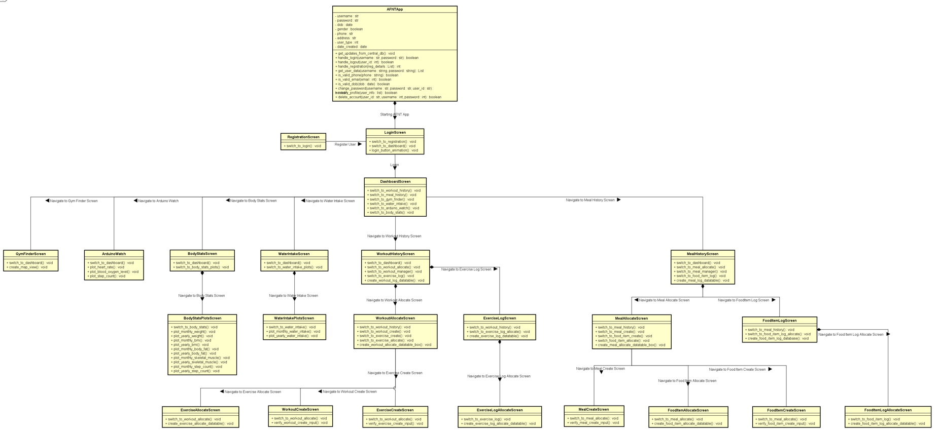

Figure 31: AFNT GUI Class Diagrams.

Using the wireframes described in ‎5.3.1, a comprehensive class diagram was devised leveraging the Kivy ScreenManager module to craft an intuitive and user-friendly UI coupled with an efficient screen management system. The class diagram encompasses 25 distinct Screen classes, each meticulously designed to execute specific tasks and functionalities, as elucidated in the following tables.

**Note**: The acronym ARMV will signify the ability to Add, Remove, Modify, or View a specific class component within the AFNT framework.

Table 28: AFNT Main Kivy GUI Class Definitions.

|  |  |  |
| --- | --- | --- |
| **Screen Name** | **Pre-condition** | **Description** |
| LoginScreen | Launch AFNT App | Managing login operation. |
| RegistrationScreen | Navigate from LoginScreen | Managing Registration operation. |
| DashboardScreen | Successfully Login | Contains options and buttons to navigate the AFNT App. |
| WaterIntakeScreen | Navigate from DashboardScreen | Responsible for managing Water Intake data (ARMV). |
| WaterIntakePlotsScreen | Select month and year then click ‘Generate Graph’ | Generates two water intake graphs, one for per selected month and one for selected year (average Water Intake per month). |
| BodyStatsScreen | Navigate from DashboardScreen | Responsible for managing Body Statistics data (ARMV). |
| BodyStatsPlotsScreen | Select month and year then click ‘Generate Graph’ on the selected Body Statistic | Generates two selected body stats graphs, one for per selected month and one for selected year. |
| GymFinderScreen | Navigate from DashboardScreen | Loads a map and displays the nearest gyms to user’s address/location in a 10mile radius, range can be modified. |

Table 29: AFNT Workouts and Exercises Kivy GUI class definitions.

|  |  |  |
| --- | --- | --- |
| **Screen Name** | **Pre-condition** | **Description** |
| LoginScreen | Launch AFNT App | Managing login operation. |
| WorkoutHistoryScreen | Navigate from DashboardScreen | Responsible for handling Workout Log data (ARMV). |
| ExerciseLogScreen | Select a Workout Log from WorkoutHistorySceen | Responsible for managing Exercise Log data (ARMV). |
| ExerciseLogAllocateScreen | Select ‘Allocate Exercise’ from ExerciseLogScreen | Responsible for allocating Exercise Logs to the selected Workout Log. |
| WorkoutAllocateScreen | Click ‘Workout Manager’ from WorkoutHistoryScreen | Responsible for allocating Workouts on selected date and time. Also manages Workout data (ARMV). |
| WorkoutCreateScreen | Click ‘Create Workout’ from WorkoutHistoryScreen | Responsible for creating Workouts. |
| ExerciseCreateScreen | Click ‘Create Exercise’ from WorkoutHistoryScreen | Responsible for creating new Exercises. |

Table 30: AFNT Meals and Food Items Kivy GUI class definitions.

|  |  |  |
| --- | --- | --- |
| **Screen Name** | **Pre-condition** | **Description** |
| MealHistoryScreen | Navigate from DashboardScreen | Responsible for handling Meal Log data (ARMV). |
| FoodItemLogScreen | Select a Meal Log from MealHistorySceen | Responsible for managing Food Item Log data (ARMV). |
| FoodItemLogAllocateScreen | Select ‘Allocate Food Item’ from FoodItemLogScreen | Responsible for allocating Food Item Logs to the selected Meal Log. |
| MealAllocateScreen | Click ‘Meal Manager’ from MealHistoryScreen | Responsible for allocating Meals on selected date and time. Also manages Meal data (ARMV). |
| MealCreateScreen | Click ‘Create Meal from MealHistoryScreen | Responsible for creating Meals. |
| FoodItemCreateScreen | Click ‘Create Food Item’ from MealHistoryScreen | Responsible for creating new Food Item. |
| MealPlotsScreen | Select month and year, then click ‘Generate Graph’ from MealHistoryScreen. | Responsible for generating meal plots. |

### AFNT Class Structure

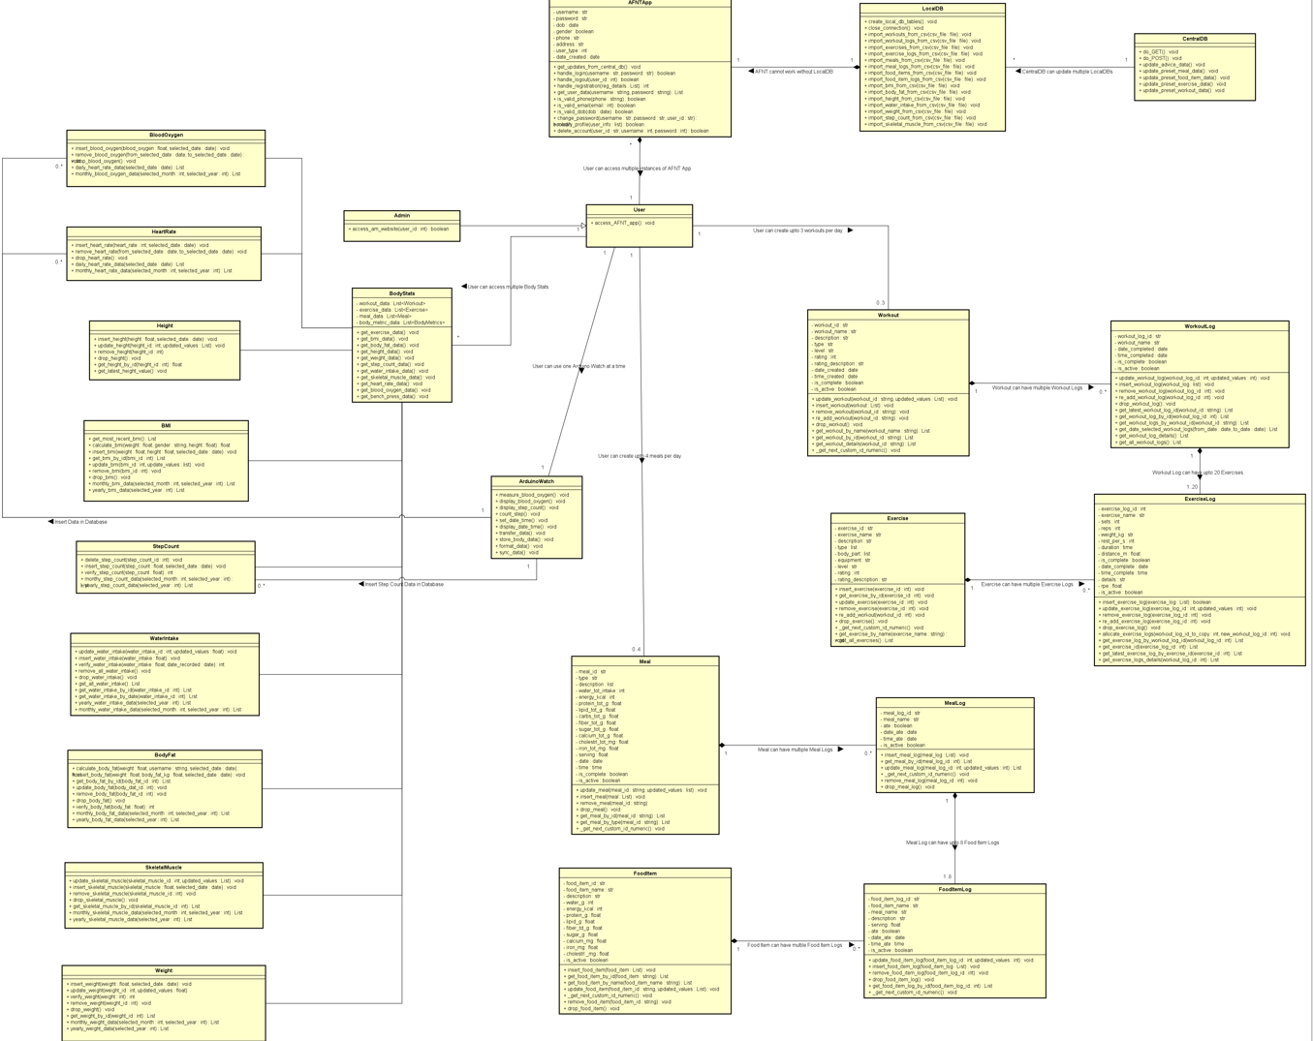

Figure 32: AFNT Class Diagram.

There are 24 classes dedicated to managing each aspect of the AFNT project. Their descriptions are provided in the below table.

Table 31: AFNT Class descriptions.

|  |  |
| --- | --- |
| **Class** | **Description** |
| AFNTApp | Responsible for launching the AFNT App and handling login, registration, and account management requests |
| LocalDB | Responsible for handing importation of data and includes the database schema. |
| CentralDB | Responsible for handling database operations and contains the database schema. |
| User | Responible for user operations |
| Admin | Responsible for CDB management and inherits all functionalities from User class. |
| ArduinoWatch | Manages the data received from the Arduino watch. Also deals with connection/synchronising with the Arduino Watch. |
| Workout | Manages all database operations for Workouts table in LDB. |
| WorkoutLog | Manages all database operations for Workout Logs table in LDB. This class has a composite relationship with the Workout class. |
| Exercise | Manages all database operations for Exercises table in LDB. |
| ExerciseLog | Manages all database operations for Exercise Logs table in LDB. This class has a composite relationship with the Exercise and WorkoutLog class. |
| Meal | Manages all database operations for Meals table in LDB. |
| MealLog | Manages all database operations for Meal Logs table in LDB. This class has a composite relationship with the Meal class. |
| FoodItem | Manages all database operations for Food Items table in LDB. |
| FoodItemLog | Manages all database operations for Food Item Logs table in LDB. This class has a composite relationship with the MealLog and FoodItem class. |
| BodyStats | Fetches all body related data from LDB. |
| BloodOxygen | Manages all functionalities related to Blood Oxygen. |
| HeartRate | Manages all functionalities related to Heart Rate. This data is only collected by the Arduino Watch. |
| Height | Manages all functionalities related to Height. |
| Weight | Manages all functionalities related to Weight. |
| BMI | Manages all functionalities related to BMI. |
| StepCount | Manages all functionalities related to Step Count. |
| WaterIntake | Manages all functionalities related to Water Intake. |
| BodyFat | Manages all functionalities related to Body Fat. |
| SkeletalMuscle | Manages all functionalities related to Skeletal Muscle. |

## Phase 4: Arduino Watch Design

Phase 4 extends Phase 3 by introducing the Arduino Fitness Watch, capable of monitoring health metrics like Heart Rate, Blood Oxygen Level, Step Count and seamlessly transferring data to the AFNT application via Bluetooth or a wired connection.

# Implementation

# Project Evaluation

# Further Work and Conclusions

# Glossary

# Table of Abbreviations

# References / Bibliography

1. Campbell, D. (2023) *More than half of humans on track to be overweight or obese by 2035 – report* *the Guardian*. 2 March 2023 [online]. Available from: https://www.theguardian.com/society/2023/mar/02/more-than-half-of-humans-on-track-to-be-overweight-or-obese-by-2035-report [Accessed 22 January 2024].
2. ‘Obesity Consequences’ (2012) *Obesity Prevention Source*. 21 October 2012 [online]. Available from: https://www.hsph.harvard.edu/obesity-prevention-source/obesity-consequences/#:~:text=The%20High%20Cost%20of%20Excess%20Weight&text=No%20less%20real%20are%20the,overweight%20does%20not%20decrease%20mortality. [Accessed 22 January 2024].
3. ‌Wright, S. and Aronne, L.J. (2012) Causes of obesity. *PubMed* [online]. 37 (5), pp. 730–732. Available from: https://link.springer.com/article/10.1007/s00261-012-9862-x [Accessed 22 January 2024].
4. Desjardins, J. (2020) *Animation: The World’s Rapid Rise in Life Expectancy, in Just 13 Seconds* *Visual Capitalist*. 11 May 2020 [online]. Available from: https://www.visualcapitalist.com/rapid-rise-in-life-expectancy/ [Accessed 23 January 2024].
5. ‌ Woessner, M.N., Tacey, A., Ariella Levinger-Limor, Parker, A., Levinger, P. and Levinger, I. (2021) The Evolution of Technology and Physical Inactivity: The Good, the Bad, and the Way Forward. *Frontiers in Public Health* [online]. 9. Available from: https://www.frontiersin.org/articles/10.3389/fpubh.2021.655491/full?&utm_source=Email_to_authors_&utm_medium=Email&utm_content=T1_11.5e1_author&utm_campaign=Email_publication&field=&journalName=Frontiers_in_Public_Health&id=655491#F1 [Accessed 23 January 2024].
6. ‌Caballero B. (2007) The Global Epidemic of Obesity: An Overview. *Epidemiologic Reviews* [online]. 29 (1), pp. 1–5. Available from: https://academic.oup.com/epirev/article/29/1/1/444345?login=false [Accessed 23 January 2024].
7. Moscaritolo, A. (2024) *The Ultimate Guide to Health and Fitness Tech for 2024* *PCMag UK*. 5 January 2024 [online]. Available from: https://uk.pcmag.com/gallery/130809/the-ultimate-guide-to-health-and-fitness-tech [Accessed 23 January 2024].
8. ‌ Pankush Kalgotra, Raja, U. and Sharda, R. (2022) Growth in the development of health and fitness mobile apps amid COVID-19 pandemic. *DOAJ (DOAJ: Directory of Open Access Journals)* [online]. 8, p. 205520762211290-205520762211290. Available from: https://www.ncbi.nlm.nih.gov/pmc/articles/PMC9536106/ [Accessed 23 January 2024].
9. ‘Fitness App Revenue and Usage Statistics (2024)’ (2024) *Business of Apps*. 8 January 2024 [online]. Available from: https://www.businessofapps.com/data/fitness-app-market/ [Accessed 23 January 2024].
10. ‌‘How to look after your mental health using exercise’ (2015) *Mental Health Foundation*. 2015 [online]. Available from: https://www.mentalhealth.org.uk/explore-mental-health/publications/how-look-after-your-mental-health-using-exercise [Accessed 17 October 2023].
11. ‌ ‘7 great reasons why exercise matters’ (2023) *Mayo Clinic*. 2023 [online]. Available from: https://www.mayoclinic.org/healthy-lifestyle/fitness/in-depth/exercise/art-20048389 [Accessed 17 October 2023].
12. ‌ Godman, H. (2014) *Regular exercise changes the brain to improve memory, thinking skills - Harvard Health* *Harvard Health*. 9 April 2014 [online]. Available from: https://www.health.harvard.edu/blog/regular-exercise-changes-brain-improve-memory-thinking-skills-201404097110 [Accessed 17 October 2023].
13. ‌ ‘How Can Exercise Affect Sleep? | Sleep Foundation’ (2013) *Sleep Foundation*. 25 February 2013 [online]. Available from: https://www.sleepfoundation.org/physical-activity/exercise-and-sleep [Accessed 17 October 2023].
14. ‌ ‘How to boost your immune system - Harvard Health’ (2014) *Harvard Health*. 22 September 2014 [online]. Available from: https://www.health.harvard.edu/staying-healthy/how-to-boost-your-immune-system [Accessed 17 October 2023].
15. www.facebook.com/thefitnessgrp (2023) *How Much Does a Gym Membership Cost in the UK (2023)* *Thefitnessgrp.co.uk*. 19 July 2023 [online]. Available from: https://www.thefitnessgrp.co.uk/how-much-does-a-gym-membership-cost/ [Accessed 25 January 2024].
16. ‘Top excuses people use for not going to the gym | Better’ (2023) *Better.org.uk*. 2023 [online]. Available from: https://www.better.org.uk/content_pages/top-gym-excuses [Accessed 25 January 2024].
17. Millington, B. (2018) *A brief history (and a look into the future) of fitness technology* *The Conversation*. 11 January 2018 [online]. Available from: https://theconversation.com/a-brief-history-and-a-look-into-the-future-of-fitness-technology-89884 [Accessed 23 January 2024].
18. ‘Healthcare - Apple Watch’ (2017) *Apple (United Kingdom)*. 2017 [online]. Available from: https://www.apple.com/uk/healthcare/apple-watch/ [Accessed 23 January 2024].
19. ‌ Waghchoure, E. (2023) *The Evolution of Fitness Trackers: Your Personal Health Companion* *Medium*. 16 September 2023 [online]. Available from: https://medium.com/@elijah.ndspl/the-evolution-of-fitness-trackers-your-personal-health-companion-5745e41ee9e2 [Accessed 23 January 2024].
20. ‘Samsung Health | Apps & Services | Samsung UK’ (2023) *Samsung uk*. 21 November 2023 [online]. Available from: https://www.samsung.com/uk/apps/samsung-health/ [Accessed 26 January 2024].
21. ‘Calorie Tracker & BMR Calculator to Reach Your Goals | MyFitnessPal’ (2024) *Myfitnesspal.com*. 2024 [online]. Available from: https://www.myfitnesspal.com/ [Accessed 26 January 2024].
22. ‘Lose It! - Calorie counting made easy’ (2022) *Loseit.com*. 2022 [online]. Available from: https://www.loseit.com/ [Accessed 26 January 2024].
23. ‘Strava | Running, Cycling & Hiking App - Train, Track & Share’ (2024) *Strava.com*. 2024 [online]. Available from: https://www.strava.com/features [Accessed 26 January 2024].
24. ‘The Fitbit App’ (2024) *Fitbit.com*. 2024 [online]. Available from: https://www.fitbit.com/global/uk/technology/fitbit-app [Accessed 26 January 2024].
25. Garmin International (2024) *Garmin Connect | Free Online Fitness Community* *Garmin Connect*. 2024 [online]. Available from: https://connect.garmin.com/ [Accessed 26 January 2024].
26. ‘Nike Training Club App. Home Workouts & More.’ (2023) *Nike.com*. 2023 [online]. Available from: https://www.nike.com/ntc-app [Accessed 24 January 2024].
27. (Beachbodyondemand, 2023) *Beachbodyondemand.com*. 2023 [online]. Available from: https://www.beachbodyondemand.com/?locale=en_US [Accessed 24 January 2024].
28. ‌‘Permissions on Android’ (2024) *Android Developers*. 2024 [online]. Available from: https://developer.android.com/guide/topics/permissions/overview#normal-dangerous [Accessed 24 January 2024].
29. ‌Olmstead, K. (2015) *Apps Permissions in the Google Play Store* *Pew Research Center: Internet, Science & Tech*. 10 November 2015 [online]. Available from: https://www.pewresearch.org/internet/2015/11/10/apps-permissions-in-the-google-play-store/ [Accessed 24 January 2024].
30. Grundy, Q., Held, F. and Bero, L. (2017) Tracing the Potential Flow of Consumer Data: A Network Analysis of Prominent Health and Fitness Apps. *Journal of Medical Internet Research* [online]. 19 (6), pp. e233–e233. Available from: https://www.jmir.org/2017/6/e233/#ref7 [Accessed 24 January 2024].
31. Li, J. (2015) A Privacy Preservation Model for Health-Related Social Networking Sites. *Journal of Medical Internet Research* [online]. 17 (7), pp. e168–e168. Available from: https://www.jmir.org/2015/7/e168/ [Accessed 24 January 2024].
32. ‘Appconner - Best Apps & Stories’ (2021) *Appconner*. 2021 [online]. Available from: https://www.appconner.com/app-samsung-health?utm_source=bing&utm_medium=cpc&utm_campaign=%e6%96%b0213b_afcapp_uk_jay%209.30%200.1*&utm_term=samsung%20health&utm_content=1830_samsung%20health* [Accessed 26 January 2024].
33. ‘Overview of UK GDPR’ (2016) *Practical Law*. 2016 [online]. Available from: https://uk.practicallaw.thomsonreuters.com/Document/I968a9c521afe11e89bf099c0ee06c731/View/FullText.html?navigationPath=Search%2Fv1%2Fresults%2Fnavigation%2Fi0ad740160000018d3e479a10da2c4879%3Fppcid%3Dc2504c02e0aa4c198285633427e0550a%26Nav%3DKNOWHOW_UK%26fragmentIdentifier%3DI968a9c521afe11e89bf099c0ee06c731%26parentRank%3D0%26startIndex%3D1%26contextData%3D%2528sc.Search%2529%26transitionType%3DSearchItem&listSource=Search&listPageSource=4be1b00a2501e5d28b058acb57e263c2&list=KNOWHOW_UK&rank=2&sessionScopeId=09fc82fad034c2252f14fe02939c428e76892af50a3a0a55be4a0ac57ed2c67c&ppcid=c2504c02e0aa4c198285633427e0550a&originationContext=Search%20Result&transitionType=SearchItem&contextData=(sc.Search)&comp=pluk [Accessed 25 January 2024].
34. WCAG 2 (2018) *WCAG 2 Overview* *Web Accessibility Initiative (WAI)*. 2018 [online]. Available from: https://www.w3.org/WAI/standards-guidelines/wcag/ [Accessed 25 January 2024].
35. ‘Powerful and Fast UML Diagramming Software - Astah’ (2023) *Astah*. September 2023 [online]. Available from: https://astah.net/products/astah-uml/ [Accessed 25 January 2024].
36. ‘Free Online Spreadsheet Software: Excel | Microsoft 365’ (2016) *Microsoft.com*. 2016 [online]. Available from: https://www.microsoft.com/en-us/microsoft-365/excel?ocid=ORSEARCH_Bing [Accessed 25 January 2024].
37. ‘SQLite Home Page’ (2024) *Sqlite.org*. 2024 [online]. Available from: https://www.sqlite.org/index.html [Accessed 25 January 2024].
38. ‘SQL Server Downloads | Microsoft’ (2022) *Microsoft.com*. 2022 [online]. Available from: https://www.microsoft.com/en-GB/sql-server/sql-server-downloads [Accessed 25 January 2024].
39. ‘Welcome to Flask — Flask Documentation (3.0.x)’ (2024) *Palletsprojects.com*. 2024 [online]. Available from: https://flask.palletsprojects.com/en/3.0.x/ [Accessed 25 January 2024].
40. ‘Kivy: Cross-platform Python Framework for NUI’ (2024) *Kivy.org*. 2024 [online]. Available from: https://kivy.org/ [Accessed 25 January 2024].
41. ‘TinyCircuits - Maker of Tiny, Open Source Electronics’ (2024) *TinyCircuits*. 2024 [online]. Available from: https://tinycircuits.com/ [Accessed 25 January 2024].
42. ‘TinyCircuits Projects’ (2022) *TinyCircuits*. 24 January 2022 [online]. Available from: https://tinycircuits.com/blogs/learn [Accessed 25 January 2024].
43. Business, A. (2022) *Chapter 10: MoSCoW Prioritisation* *Agilebusiness.org*. 2022 [online]. Available from: https://www.agilebusiness.org/dsdm-project-framework/moscow-prioririsation.html [Accessed 22 March 2024].
44. Alam, M. (2022) *7 Crucial UML Diagram Advantages* *IdeaScale*. 16 March 2022 [online]. Available from: https://ideascale.com/blog/uml-diagram-advantages/ [Accessed 22 March 2024].
45. Atlassian (2019) *What is kanban?* *Atlassian*. 2019 [online]. Available from: https://www.atlassian.com/agile/kanban#:~:text=Kanban%20is%20one%20of%20the,for%20teams%20of%20all%20sizes. [Accessed 22 March 2024].
46. Pandit, N. (2022) *Gym Exercise Dataset* *Kaggle.com*. 2022 [online]. Available from: https://www.kaggle.com/datasets/niharika41298/gym-exercise-data/data [Accessed 23 March 2024].
47. vinitshah0110 (2022) *Food Composition* *Kaggle.com*. 2022 [online]. Available from: https://www.kaggle.com/datasets/vinitshah0110/food-composition [Accessed 23 March 2024].
48. ‘Body Fat Calculator’ (2017) *Calculator.net*. 2017 [online]. Available from: https://www.calculator.net/body-fat-calculator.html [Accessed 23 March 2024].
49. ‘BMI Calculator’ (2024) *Calculator.net*. 2024 [online]. Available from: https://www.calculator.net/bmi-calculator.html [Accessed 23 March 2024].
50. ‌

‌

# Appendix A: Requirements

## Project Aim

To design and implement a software solution focused on helping users achieve their fitness objectives. This involves developing a user-friendly platform for creating and customising workout routines, monitoring nutrition and workout progress, and offering health and fitness guidance. The main aim is to build an engaging and efficient fitness tool that encourages users to live healthier, more active lives.

## Project Objectives

Please note all requirements will be marked by MoSCow Prioritization technique.

|  |  |  |  |
| --- | --- | --- | --- |
| **ID** | **Objective** | **Description** | **Created** |
| O1 | Develop a Scalable and Secure Database Management System (DBMS) | Develop a scalable MySQL DBMS, including a central database for 2,000+ records and a local database for user data and watch data. Improve database performance and security and ensure GDPR compliance. | 09/10/2023 |
| O2 | Build the Alistana Fitness & Nutrition Tracker (AFNT) Application | Develop the AFNT application with features for workout and nutrition tracking, body progress and measurement tracking. Should be connected to DBMS, Admin Management website (only for Admins), and Arduino watch. | 09/10/2023 |
| O3 | Design a User-Centric Admin Management (AM) Website | Develop a responsive website with secure login and allows Admins to edit the central database (user login data and preset workout and meal data) and app push updates to the AFNT application. The website will prioritize a user-friendly design, encrypted communication, and security measures. | 09/10/2023 |
| O4 | Design and develop a Fitness Watch using Arduino | Create an Arduino-based Fitness watch to measure blood oxygen level, heart rate and step count, and investigate ways of connecting the Arduino watch to the AFNT and store body data in the local database via AFNT. | 16/10/2023 |
| O5 | Enhance Code Quality and Performance | Implement clean, maintainable code with 80% code coverage. Optimize application and website response times to under 2 and 3 seconds, respectively. | 25/10/2023 |

## Functional Requirements

The functional requirements are divided into 4 categories: Database, Website, Application and Arduino Watch. These categories may be divided into further sub-categories to make them more readable, making it easier to track progress.

### Database

|  |  |  |  |  |
| --- | --- | --- | --- | --- |
| **Database Management System (DBMS)** | | | | |
| **ID** | **Summary** | **Priority** | **Status** | **Created** |
| **Central Database (CDB)** | | | | |
| FD1 | The central database should be stored in a MySQL Server. | M | Partially Complete | 25/10/2023 |
| FD2 | Should store preset meals, food items, exercises, and workouts with attributes such as meal_id, food_item_id, exercise_id, and workout_id. | M | Complete | 11/10/2023 |
| FD3 | Store user information in CDB with attributes such as user, email, password hash, type (User or Admin), gender, phone, address, and date created. | M | Complete | 25/10/2023 |
| FD4 | Support queries to retrieve preset meals, food items, exercises, and workouts based on various filters such as meal type, food category, exercise category, and workout difficulty. | M | Partially Complete | 25/10/2023 |
| FD5 | Provide data synchronization capabilities to update the local database with the latest preset data by comparing the timestamps of the local and central databases. | M | Partially Complete | 25/10/2023 |
| **Local Database (LDB)** | | | | |
| FD6 | The local database should be stored in the user drive using SQLite. | M | Complete | 25/10/2023 |
| FD7 | Store both preset and custom (combined as one) in tables: meals, meal_logs food_items, food_item_logs. exercises, exercise_logs workouts, workout_logs, heart rate, blood oxygen level, and step count. | M | Complete | 16/10/2023 |
| FD8 | Store user information in LDB with attributes such as user, email, password hash, type (User or Admin), gender, phone, address, and date created. | M | Complete | 16/10/2023 |
| FD9 | Support updates to custom meals, workouts, exercises, and health metrics by allowing users to add, modify, and delete records. | M | Complete | 09/10/2023 |
| FD10 | Store health metrics from the Arduino watch including step count, heart rate and blood oxygen level. | M | Complete | 17/10/2023 |
| FD11 | Store other metrics such as height (meters), weight (kg), BMI, skeletal muscle (kg), body fat (%) and water intake (ml), | M | Complete | 26/10/2023 |

### Website

|  |  |  |  |  |
| --- | --- | --- | --- | --- |
| **Admin Management Website (AM)** | | | | |
| **ID** | **Summary** | **Priority** | **Status** | **Created** |
| FW1 | The AFNT App shall link to the AM website for Admin login. | S | Not Started | 09/10/2023 |
| FW2 | The website should only be accessible to Admins and can be accessed Online or via AFNT App. | S | Partially Complete | 09/10/2023 |
| FW3 | The website shall allow Admin users to log in securely with their credentials. | S | Complete | 09/10/2023 |
| FW6 | The website shall allow admins to modify user personal details (i.e., profile picture, name, age, gender, dob, email, password, phone, address, and postcode. | C | Not Implementing | 09/10/2023 |
| FW7 | The website shall allow admins to edit their own profiles (profile picture, name, age, gender, dob, email, password, phone, address, and postcode). | C | Not Implementing | 09/10/2023 |
| FW8 | The website should allow admins to add/modify/delete preset workout data | M | Not Implementing | 09/10/2023 |
| FW9 | The website should allow admins to add/modify/delete preset exercise data | M | Not Implementing | 09/10/2023 |
| FW10 | The website should allow admins to add/modify/delete preset meal data | M | Not Implementing | 09/10/2023 |
| FW11 | The website should allow admins to add/modify/delete preset food item data | M | Not Implementing | 09/10/2023 |
| FW12 | The website shall allow admins to push database updates to the AFNT application. | M | Not Implementing | 10/10/2023 |

### Application

|  |  |  |  |  |
| --- | --- | --- | --- | --- |
| **Alistana Fitness & Nutrition Tracker Application (AFNT)** | | | | |
| **ID** | **Summary** | **Priority** | **Status** | **Created** |
| **Login and Registration** | | | | |
| FA41 | The application shall allow users to login using their username and password credentials. | M | Complete | 17/10/2023 |
| FA42 | The application shall allow users to register, and they must provide details such as username, email, password, phone number, email address, address, date of birth and gender. | M | Complete | 17/10/2023 |
| **User Profile** | | | | |
| FA43 | The application shall allow users to modify their personal data such as profile picture, username, email, password, phone number, email address, address, date of birth and gender. | M | Partially Complete | 17/10/2023 |
| FA44 | The application shall allow users to delete their personal data. | M | Partially Complete | 17/10/2023 |
| FA45 | The application shall allow users to delete their account and all the data associated with it. | M | Partially Complete | 17/10/2023 |
| **Workout Tracker** | | | | |
| FA1 | The application shall allow users to create their own workout plans. | M | Partially Complete | 09/10/2023 |
| FA2 | The application shall allow users to customize their own workout plans. | M | Partially Complete | 09/10/2023 |
| FA3 | The application shall allow users to choose pre-designed workout plans based on their goals. | M | Partially Complete | 09/10/2023 |
| FA4 | The application shall allow users to receive suggested workouts based on fitness goals. | S | Partially Complete | 09/10/2023 |
| FA5 | The application shall allow users to track their workouts by recording exercises, sets, reps, and weights (For custom exercises). | M | Partially Complete | 09/10/2023 |
| FA6 | The application shall allow users to rate their performance for each exercise (For both preset and custom). | M | Partially Complete | 09/10/2023 |
| FA7 | The application shall allow users to rate their performance for each workout (For both preset and custom). | M | Partially Complete | 09/10/2023 |
| FA8 | The application shall allow users to view their workout logs (For both preset and custom). | M | Partially Complete | 09/10/2023 |
| FA9 | The application shall allow users to view their exercise logs (For both preset and custom). | M | Partially Complete | 09/10/2023 |
| FA10 | The application shall allow users to display graphs of each exercise progress (i.e., Bench press max weight every month). | M | Partially Complete | 09/10/2023 |
| FA11 | The application shall allow users to display graphs of cardio-related exercises (i.e., Step/Distance for treadmill session) by manually inputting the information. | M | Partially Complete | 23/10/2023 |
| FA12 | The application shall allow users to display graphs of cardio-related exercises (i.e., Step/Distance for treadmill session) provided by the Arduino watch. | M | Not Started | 23/10/2023 |
| FA13 | The application shall produce charts for weight in kilogram (per day). | M | Complete | 26/10/2023 |
| FA14 | The application shall allow users to set goals for workouts. | C | Not Started | 24/10/2023 |
| **Nutrition Tracker** | | | | |
| FA15 | The application shall allow users to select preset food items. | M | Partially Complete | 09/10/2023 |
| FA16 | The application shall allow users to select preset meals. | M | Partially Complete | 09/10/2023 |
| FA17 | The application shall allow users to create custom food items and define their nutritional contents (i.e., calories, protein, carbs, fats etc.) | M | Partially Complete | 09/10/2023 |
| FA18 | The application shall allow users to create custom meals and add food items (Both custom and preset) to the custom meal. | M | Partially Complete | 26/10/2023 |
| FA19 | The application shall allow users to modify custom food items. | M | Partially Complete | 09/10/2023 |
| FA20 | The application shall allow users to modify custom meals. | M | Partially Complete | 09/10/2023 |
| FA21 | The application shall allow users to input daily water intake in milliliters (per day). | M | Partially Complete | 09/10/2023 |
| FA22 | The application shall allow users to generate a daily calorie intake graph based on a selected date range. | M | Not Started | 24/10/2023 |
| FA23 | The application shall allow users to generate a daily nutritional content intake (i.e., Carbs, fat, protein intake per day) graph based on a selected date range. | M | Not Started | 24/10/2023 |
| FA24 | The application shall allow users to generate a daily water intake graph based on a selected date range. | M | Not Started | 24/10/2023 |
| FA25 | The application shall allow users to set goals for nutritional intake. | C | Not Started | 25/10/2023 |
| FA26 | The application shall allow users to set goals for their water intake | C | Not Started | 25/10/2023 |
| **Body Measurements Tracker** | | | | |
| FA27 | The application shall allow users to input their daily weight in kilograms (per day). | M | Complete | 26/10/2023 |
| FA28 | The application shall allow users to input their daily height in meters (per day). | M | Complete | 26/10/2023 |
| FA29 | The application shall allow users to input Skeletal muscle data in kilograms (per day). | M | Complete | 26/10/2023 |
| FA30 | The application shall allow users to input Body fat data in percentage (per day). | M | Complete | 26/10/2023 |
| FA31 | The application shall use weight and height data and calculate user’s BMI (per day). | M | Complete | 26/10/2023 |
| FA32 | The application shall produce charts for weight in kilogram (per day). | M | Complete | 26/10/2023 |
| FA33 | The application shall produce graphs for height change. | M | Complete | 26/10/2023 |
| FA34 | The application shall produce charts for BMI change. | M | Complete | 26/10/2023 |
| FA35 | The application shall allow users to set goals for step counts/distance covered per day. | M | Complete | 26/10/2023 |
| FA36 | The application shall allow users to generate a heart rate graph provided by the Arduino watch. | M | Partially Complete | 26/10/2023 |
| FA37 | The application shall allow users to generate a blood oxygen chart provided by the Arduino watch. | M | Partially Complete | 26/10/2023 |
| **Gym Locator** | | | | |
| FA38 | The application shall allow users to get a list of the nearest gyms based on a mapping API. | S | Partially Complete | 24/10/2023 |
| **Health & Nutrition Advice** | | | | |
| FA39 | The application shall allow users to access health-related advice. | W | Not Implementing | 09/10/2023 |
| FA40 | The application shall allow users to access fitness-related advice (i.e., correct exercise forms etc.). | W | Not Implementing | 09/10/2023 |

### Arduino Watch

|  |  |  |  |  |
| --- | --- | --- | --- | --- |
| **Arduino Fitness Watch** | | | | |
| **ID** | **Summary** | **Priority** | **Status** | **Created** |
| FAW1 | The watch shall display the current date and time. | M | Partially Complete | 16/10/2023 |
| FAW1 | The watch shall have an oximeter module attached to measure heart rate and blood oxygen levels in real-time. | M | Not Started | 16/10/2023 |
| FAW2 | The watch shall have an accelerometer module attached to measure steps in real-time. | M | Partially Complete | 16/10/2023 |
| FAW3 | The watch shall also use the accelerometer to count reps for the bench press in real-time. | M | Partially Complete | 18/10/2023 |
| FAW4 | The watch shall have a microSD storage unit to store body measurements in real-time. | M | Partially Complete | 18/10/2023 |
| FAW5 | The watch shall compile, and store measured data in a CSV file type. | M | Not Started | 18/10/2023 |
| FAW6 | The watch shall use a Bluetooth (low energy) module to transfer data to the application. | M | Not Started | 18/10/2023 |
| FAW7 | The watch shall also use a wired connection via a micro-USB port to transfer watch data to the application. | M | Partially Complete | 18/10/2023 |
| FAW8 | The application shall process and store watch data in the local database. | M | Not Started | 18/10/2023 |

## Non-Functional Requirements

The non-functional requirements are divided into 9 categories: Application, Performance, Efficiency & Sustainability, Data Storage Optimization, Privacy & Security, Reliability, Usability, Data Backup & Recovery, and Third-Party Service Integration. These categories may be divided into further sub-categories to make them more readable, making it easier to track progress.

### Application:

|  |  |  |  |  |
| --- | --- | --- | --- | --- |
| **Alistana Fitness & Nutrition Tracker Application (AFNT)** | | | | |
| **ID** | **Summary** | **Priority** | **Status** | **Created** |
| **Workout Tracker** | | | | |
| NFA1 | Users can add an unlimited number of custom exercises | M | Complete | 25/10/2023 |
| NFA2 | Users can add an unlimited number of custom workouts | M | Complete | 25/10/2023 |
| NFA3 | Users cannot modify preset workouts and exercises. | M | Complete | 25/10/2023 |
| NFA4 | Users can allocate three workouts per day. | M | Complete | 25/10/2023 |
| NFA5 | Users can choose up to 20 exercises (incl. custom exercises) per workout. | M | Complete | 25/10/2023 |
| NFA6 | Users cannot modify preset workouts and exercises. | M | Complete | 25/10/2023 |
| **Nutrition Tracker** | | | | |
| NFA8 | Users can add an unlimited number of custom food items | M | Partially Complete | 25/10/2023 |
| NFA9 | Users can add an unlimited number of custom meals | M | Partially Complete | 25/10/2023 |
| NFA10 | Users cannot modify preset food items and meals. | M | Partially Complete | 25/10/2023 |
| NFA11 | Users can modify meal logs and food item serving size in that meal (Can be both custom or preset meal and food item.) | M | Partially Complete | 26/10/2023 |
| NFA12 | Users can only select up to 4 meals (Morning, Afternoon, Evening, and Dinner) per day. | M | Not Started | 25/10/2023 |
| NFA13 | Users can choose up to 8 food items (incl. custom food items) per meal. | M | Not Started | 25/10/2023 |
| NFA14 | Users cannot modify the nutrition content of preset meals and food items. | M | Partially Complete | 25/10/2023 |

### Performance:

|  |  |  |  |  |
| --- | --- | --- | --- | --- |
| **Performance** | | | | |
| **ID** | **Summary** | **Priority** | **Status** | **Created** |
| NFP1 | The AM website should load in under 5 seconds, ensuring optimal user experience | S | Complete | 09/10/2023 |
| NFP2 | The AM website shall respond to user input within 200 milliseconds, providing a smooth and responsive interaction. | S | Partially Complete | 09/10/2023 |
| NFP3 | The application shall load within a 5-second time frame, ensuring users can access the features promptly. | S | Complete | 09/10/2023 |
| NFP4 | The Arduino watch should display heart rate, blood oxygen level, steps count in real time on the watch display. | M | Not Started | 17/10/2023 |

### Efficiency & Sustainability:

|  |  |  |  |  |
| --- | --- | --- | --- | --- |
| **Efficiency & Sustainability** | | | | |
| **ID** | **Summary** | **Priority** | **Status** | **Created** |
| NFES1 | The AM website should have a memory usage of no more than 500 MB and a CPU usage of no more than 10% under normal operating conditions. | C | Complete | 09/10/2023 |
| NFES2 | The application should have a memory usage of no more than 250 MB and a CPU usage of no more than 5% under normal operating conditions. | C | Complete | 25/10/2023 |
| NFES3 | The watch should collect and store data with a latency of no more than 100 milliseconds and a storage usage of no more than 50 MB. | C | Not Started | 24/10/2023 |
| NFES4 | The watch should transfer data to the application with a latency of no more than 200 milliseconds and a data transfer rate of at least 1 Mbps. | C | Not Started | 24/10/2023 |
| NFES5 | Ensure database consistency and integrity by implementing ACID (Atomicity, Consistency, Isolation, Durability) properties in database transactions. | C | Complete | 25/10/2023 |

### Data Storage Optimization:

|  |  |  |  |  |
| --- | --- | --- | --- | --- |
| **Data Storage & Optimization** | | | | |
| **ID** | **Summary** | **Priority** | **Status** | **Created** |
| NFDS1 | Implement efficient data storage techniques such as indexing, partitioning, and normalization to ensure that the average database query time is no more than 200 milliseconds for read queries and no more than 500 milliseconds for write queries. | S | Complete | 09/10/2023 |

### Privacy & Security:

|  |  |  |  |  |
| --- | --- | --- | --- | --- |
| **Privacy & Security** | | | | |
| **ID** | **Summary** | **Priority** | **Status** | **Created** |
| NFPS1 | The system shall implement features such as data minimization, purpose limitation, data portability, and the right to be forgotten, to comply with GDPR guidelines. | C | Partially Complete | 09/10/2023 |
| NFPS2 | The system shall implement role-based access control, secure authentication and authorization mechanisms, and regular security audits to ensure data privacy and security for user personal and health data. | W | Partially Complete | 09/10/2023 |
| NFPS3 | User data, both at rest and in transit, shall be encrypted using industry-standard encryption algorithms (e.g., AES-256) to ensure data is stored and transmitted safely. | C | Partially Complete | 24/10/2023 |
| NFPS4 | The Bluetooth or wired data transfer from the Arduino watch to the app shall use secure protocols (e.g., TLS/SSL) and industry-standard encryption algorithms (e.g., AES-256) to ensure the data is transferred securely and encrypted. | S | Not Started | 24/10/2023 |

### Reliability:

|  |  |  |  |  |
| --- | --- | --- | --- | --- |
| **Reliability** | | | | |
| **ID** | **Summary** | **Priority** | **Status** | **Created** |
| NFR1 | The AM website will have an uptime of at least 99.9% by implementing robust error handling and failover mechanisms. | S | Partially Complete | 10/10/2023 |
| NFR2 | The application shall implement robust error handling to ensure that any errors are gracefully handled, and logged for analysis and that the application recovers without crashing. | M | Partially Complete | 24/10/2023 |
| NFR3 | The database and server shall implement robust error handling to automatically recover from failures and backup mechanisms to ensure data is backed up at least once a day and can be restored within 24 hours in case of data loss. | M | Partially Complete | 09/10/2023 |
| NFR4 | The Arduino hardware shall be constructed with materials that meet industry standards for wearables. | C | Partially Complete | 16/10/2023 |
| NFR5 | The smartwatch shall have a power management system that optimizes battery usage to ensure at least 12 hours of continuous operation on a single charge under normal usage conditions. | C | Partially Complete | 16/10/2023 |

### Usability:

|  |  |  |  |  |
| --- | --- | --- | --- | --- |
| **Usability** | | | | |
| **ID** | **Summary** | **Priority** | **Status** | **Created** |
| NFU1 | The AM website shall follow WCAG 2.1 AA compliance, as verified by automated testing tools. | C | Partially Complete | 09/10/2023 |
| NFU2 | The application shall have a user-friendly interface with a System Usability Scale (SUS) score of at least 70, indicating good usability. | C | Partially Complete | 24/10/2023 |
| NFU3 | The AM website UI shall have a navigation menu that is clearly visible and accessible from all pages, and a user flow that requires no more than three clicks to reach any page. | S | Partially Complete | 25/10/2023 |
| NFU4 | The website and application shall implement features such as screen reader compatibility, keyboard navigation, and text alternatives for non-text content to enhance accessibility for users with disabilities. | W | Not Implementing | 25/10/2023 |
| NFU5 | The application shall synchronize health data from the smartwatch to the app by pressing a sync button, ensuring that the data is up-to-date and accurate. | M | Not Started | 16/10/2023 |
| NFU6 | The application shall display clear and informative error messages in case of data transfer issues from the watch and provide a troubleshooting guide in the help section of the app. | S | Not Started | 16/10/2023 |
| NFU7 | The application should be compatible with mobile platforms, providing seamless functionality and usability across various mobile devices.  The responsiveness and compatibility standards should adhere to  modern design principles, facilitating accessibility and usability for  users on different devices. | S | Partially Complete | 16/10/2023 |

### Data Backup & Recovery:

|  |  |  |  |  |
| --- | --- | --- | --- | --- |
| **Data Backup & Recovery** | | | | |
| **ID** | **Summary** | **Priority** | **Status** | **Created** |
| NFDBR1 | The system shall have an automated backup and recovery system that creates daily backups of the database and stores them in a secure location, with the ability to restore data within 24 hours in case of data loss. | M | Complete | 09/10/2023 |
| NFDBR2 | The program's source code shall be backed up regularly to GitHub, with automated daily backups to OneDrive for additional redundancy. The backup system should support version control, allowing for the recovery of specific versions of the code if needed. | M | Complete | 09/10/2023 |

### Third-Party Service Integration:

|  |  |  |  |  |
| --- | --- | --- | --- | --- |
| **Third-Party Service Integration** | | | | |
| **ID** | **Summary** | **Priority** | **Status** | **Created** |
| NFTPS1 | The system shall integrate with mapping APIs to provide location-based services such as gym locator. The integration should be seamless, with real-time data synchronization and minimal latency. | C | Complete | 09/10/2023 |